## 

## CSE250 : Database Management System Winter Semester 2021

Guided by Professor Shefali Naik

Project Title:  
Event Management System

|  |  |
| --- | --- |
| Name | Enrolment Number |
| Malav Doshi | AU1940017 |
| Samkit Kundalia | AU1940021 |
| Parth Shah | AU1940065 |

## 

## Index

Description 4

System Requirements 5

Initialisation 5

Running 6

Entity-Relationship Diagram(🔗) 7

Table Design 12

List of all the tables in the database 12

Describing the account_table 12

Describing the bill 12

Describing the department 13

Describing the event_table 13

Describing the feedback 13

Describing the inventory 13

Describing the login 14

Describing the registration 14

Describing the sponsors 14

Describing the sponsorship_package 14

Describing the team 15

Describing the vendors 15

Queries to create tables(🔗) 16

Queries to insert data(🔗) 18

Stored Procedures and Functions 18

Following procedure provides a filter of events according to the venue. We also call a function to show the number of upcoming events. 18

Filtervenue procedure on the frontend 19

Code in backend used to call the procedure 19

Following procedure provides us the list of attendees of a particular event. 20

Output on the front-end when we call the procedure registeredUsers() 20

Following procedure provides us with the total collection of the event where we pass the event name and the fees in the entry fees in a particular event as parameters. 21

Output on the front-end when we call the procedure total_collection() 21

Code in backend used to call the procedure 21

Following procedure helps the user to get in touch with members of the event team in a particular department. 22

Output when we call the procedure contact_us() on the frontend 22

Code in backend used to call the procedure 22

Following procedure takes the feedback message as it’s parameter. It makes an API call in real time through Python which parses in the message from MySQL and returns the sentiment of the message. This saves countless hours that is spent on reading and understanding the messages in detail. 23

Input message, category 1: 23

Returned sentiment of joy: 24

Input message, category 2: 24

Returned sentiment of sadness: 25

Following bill provides the user with the bill of registration of the event that one did. 25

Output when we call the procedure customer_bill() on the frontend 26

Code in backend used to call the procedure 26

Following procedure displays all the sponsors of a particular event. 27

Output when we call sponsor_event() on the front-end 27

Code in backend used to call the procedure 28

Following function displays the number of events that are upcoming in a particular venue. 28

Code in backend used to call the procedure 29

Following function calculates the total amount associated with a particular bill. 29

Procedure called to populate the Final Amount field 30

Python code that implements this to the Frontend 31

Following function displays the total number of sponsors associated with a particular event. 32

Output when we call the function event_spcount() on the frontend 32

Triggers 33

Trigger to display error messages by checking whether the email exists in the database on inserting and updating . 33

Entering a normal email address: 34

Data added successfully: 34

Trigger fired successfully: 34

Connection with the Frontend 35

Trigger to check whether or not is the email valid on inserting and updating 36

Adding an abnormal email to fire the trigger: 36

Trigger fired successfully: 36

Connection with the Frontend 37

Trigger to delete records from child table registration , feedback and sponsors when deleted in the parent table event_table. 38

Following is the database before deleting from Event Table 38

Following is the database before deleting from Sponsors. 38

Following is the database before deleting from Registration. 39

Trigger to delete records from child table bill, registration,feedback when deleted in the parent table login. 39

Following is the data before any record is deleted from login 40

Following is the data from bill table 40

Following is registration table before delete 40

Following is the feedback table before delete 41

Trigger to delete records from the child table team, vendors when deleted in the parent table department. 41

Following is the department table before deleting 41

Following is the table vendors before delete 42

Following is the table team before delete 42

Trigger to update records from child table registration , feedback and sponsors when deleted in the parent table event_table. 43

Trigger to delete records from child table registration , feedback and sponsors when deleted in the parent table event_table. 43

## 

## Description

We have developed an Event Management System keeping in mind the end users and stakeholders like - guests, registered participants, organising team, vendors and sponsors.

On the homepage of the system, the logged in users can check any upcoming events with all details for them. They may also register (RSVP) for it. Registering for the event executes a trigger which sends them the confirmation for the same.

The organisers (admin) level users can add events and other details. They can also view the finances of the event - including sponsorship packages, vendors, inventory and registration fees.

Each organising team is divided into departments and teams. It is to smoothen the process and execution of events by sharing responsibilities. Each department has a relation to the vendor to coordinate and communicate with them for event preparations. Each material/item brought from the vendor is stored in the inventory which provides detailed records - and prevents the scope for any future unwanted expenses.

There are sponsorship packages for sponsors to choose from for events. Each sponsor can sponsor any number of events based on those packages provided and seek for deliverables.

We have also created a facility for handling finances related to the event. Each transaction is recorded for accountability - including registration fees, vendor bills, sponsorship payments and other miscellaneous incomes/expenses. The registration fees are logged into the billing system

We have also created a mailing system to remind guests and ask for feedback - post event - which is then forwarded to the team for review.

## System Requirements

1. Any Web Browser
2. Python (or Python3)
3. MySQL

## Initialisation

1. Open terminal/git bash in your system
2. !git clone <https://github.com/parthmshah1302/DBMS-Event-Management-System>
3. !cd DBMS-Event-Management-System
4. !pip install virtualenv
5. !python -m virtualenv env
6. !.\env\Scripts\activate
7. !pip install -r requirements.txt
8. Run the DBMS-EVS.sql, DBMS-Insert.sql and DBMS-ProcFuncTrig.sql from /SQLFiles in that particular order.
9. Create a db.yaml file in your project’s root directory.
10. Make sure your db.yaml file looks like this:

mysql_host: 'localhost'

mysql_user: 'root'

mysql_password: <ROOT-PASSWORD>

mysql_db: 'dbmsEventManagement'

1. !python app.py

## Running

1. !cd DBMS-Event-Management-System
2. !.\env\Scripts\activate
3. !python app.py

Now your Event Management System is running on <http://127.0.0.1:5000>

## 

## [Entity-Relationship Diagram](https://miro.com/app/board/o9J_lJQ9p5s=/)(🔗)

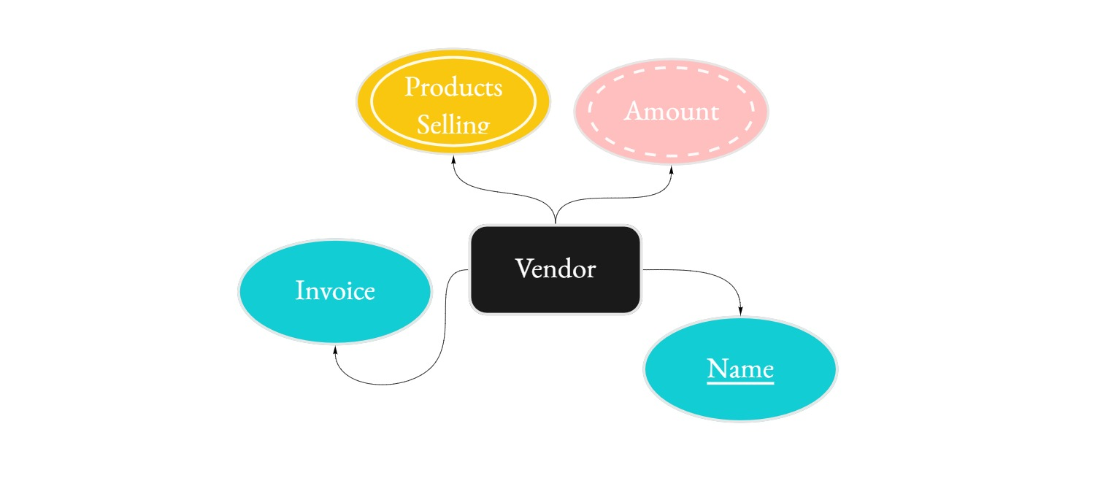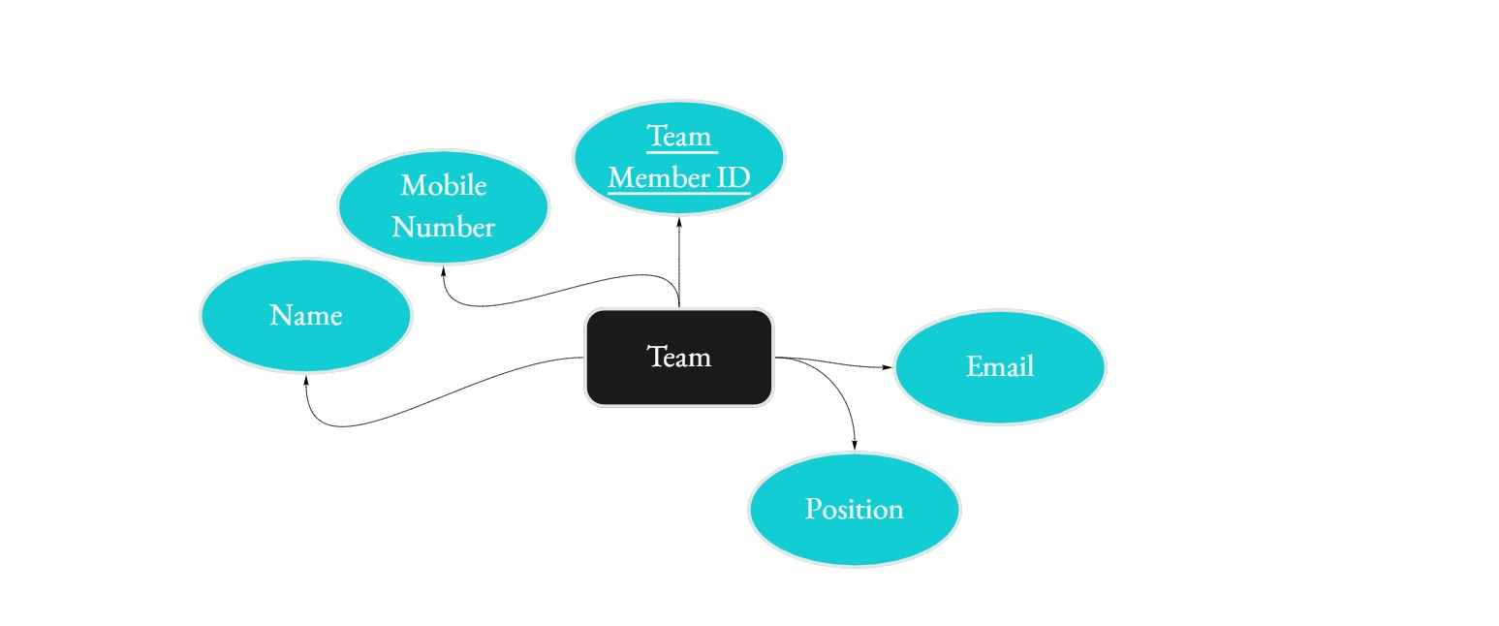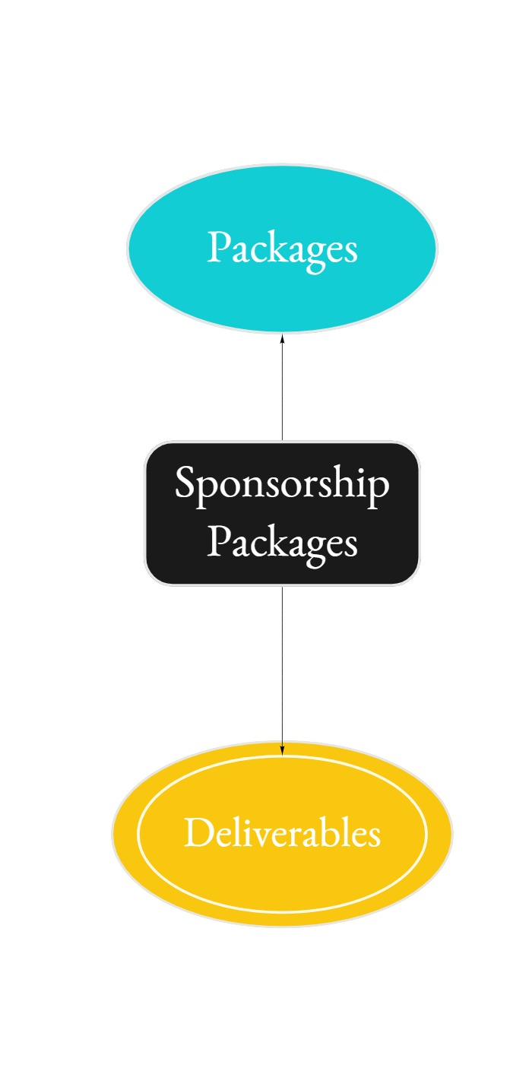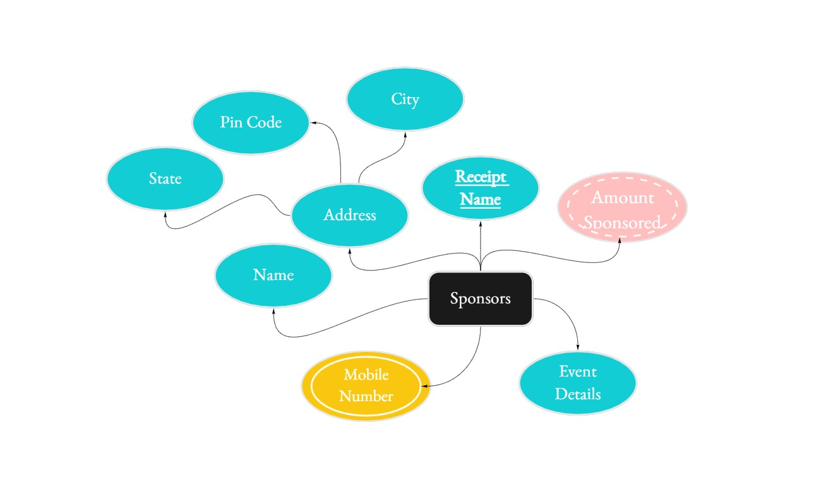

## 

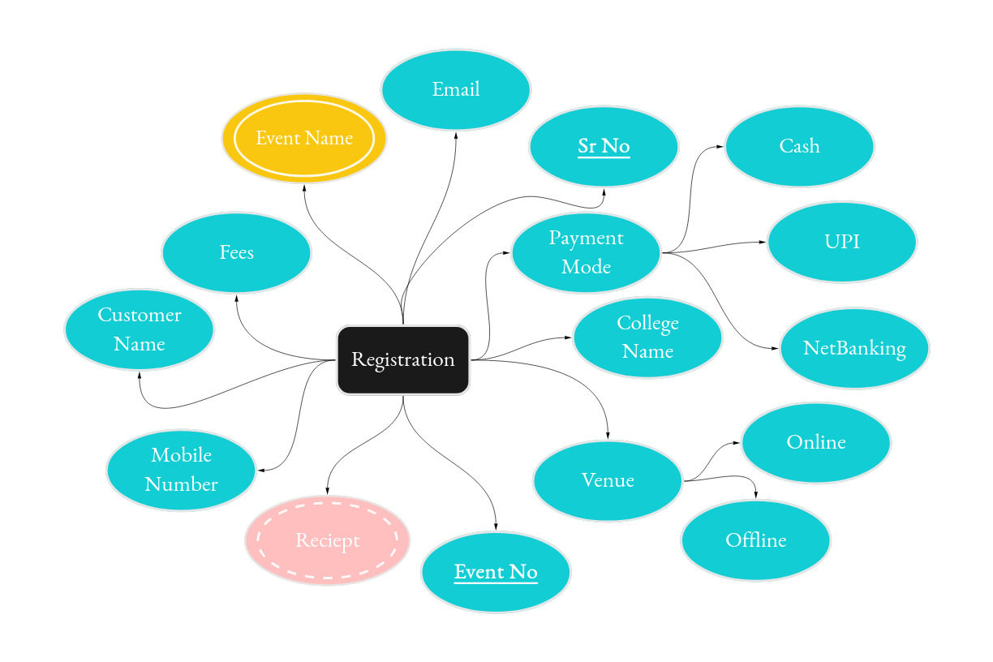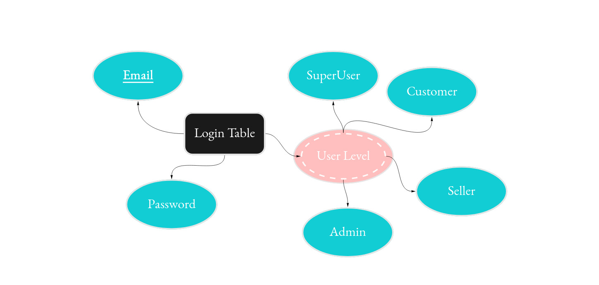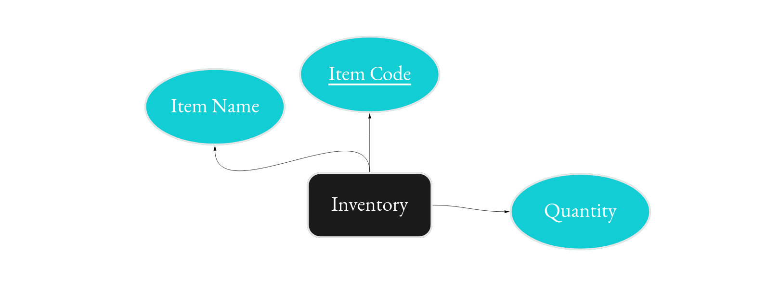

## 

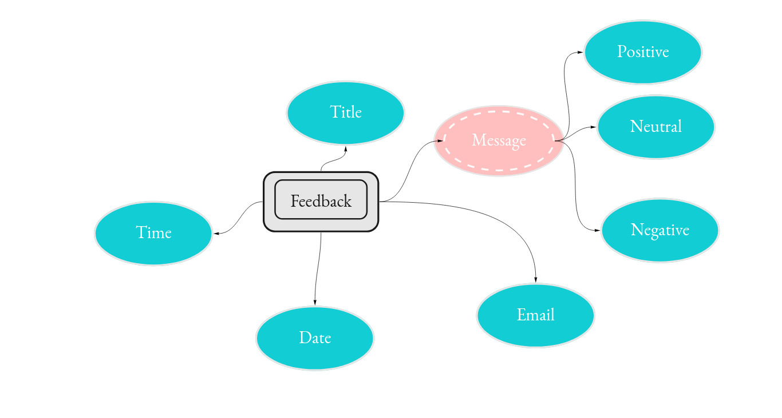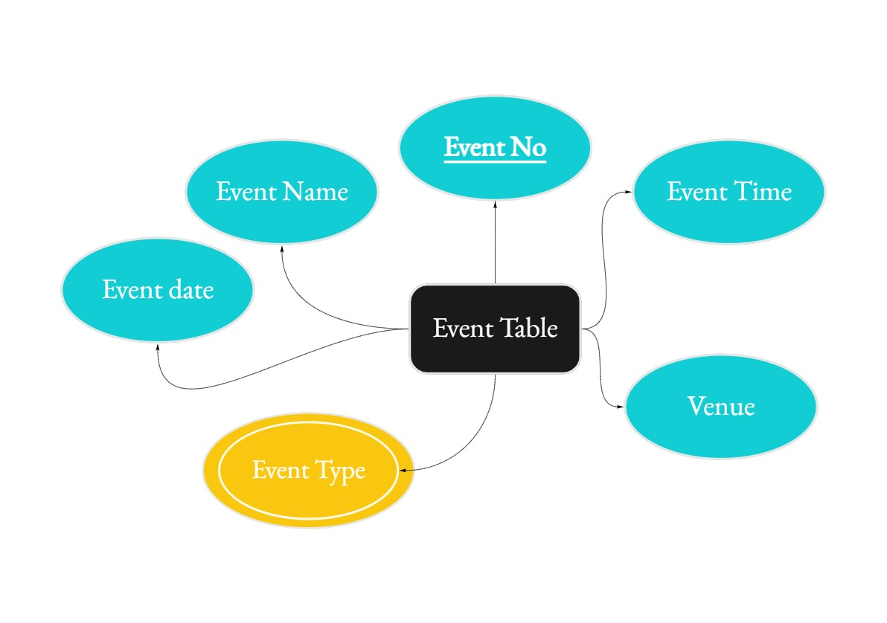

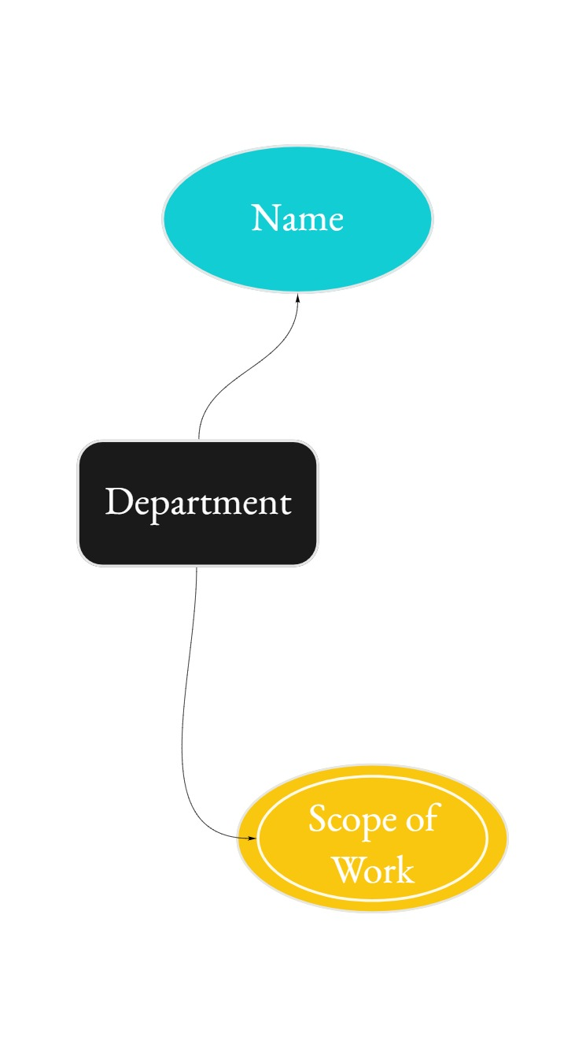

## 

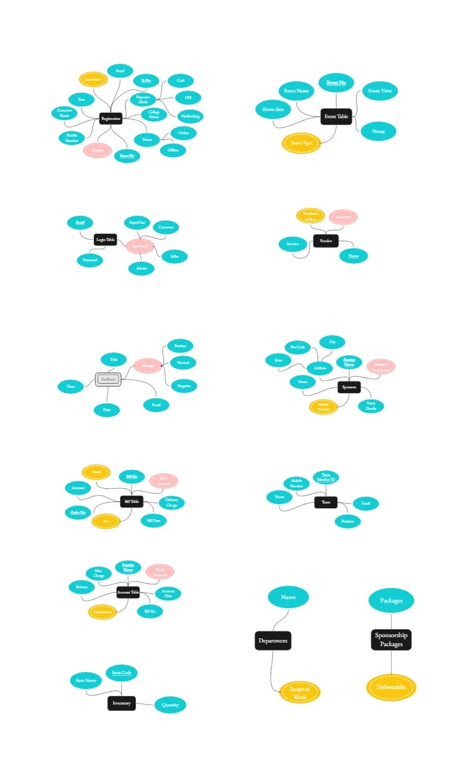

## 

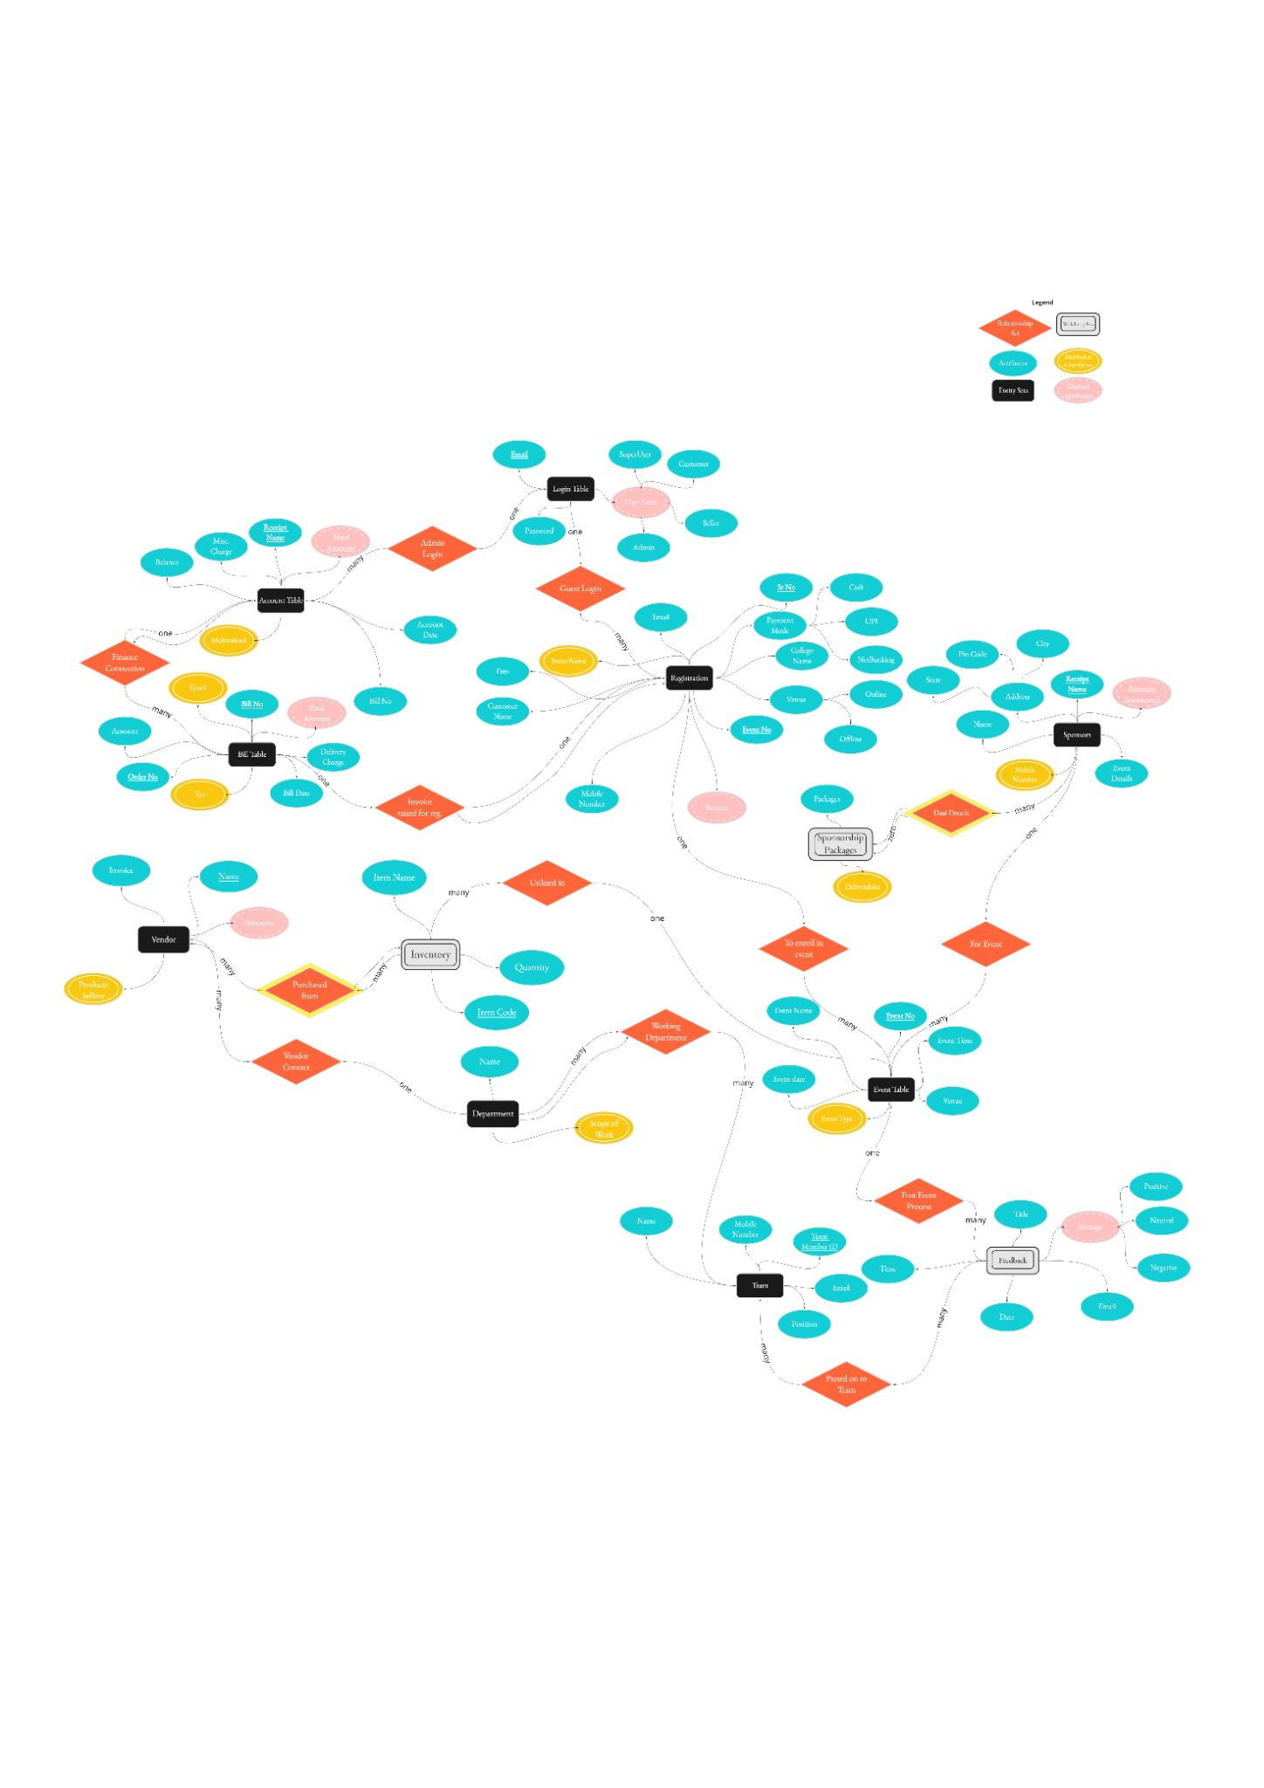

*Please visit* [*https://miro.com/app/board/o9J_lJQ9p5s=/*](https://miro.com/app/board/o9J_lJQ9p5s=/) *for full quality ER Diagram*

## 

## Table Design

#### List of all the tables in the database

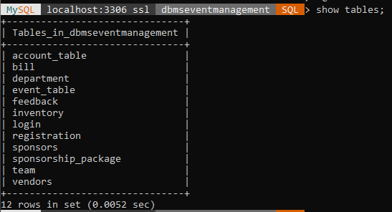

#### Describing the *account_table*

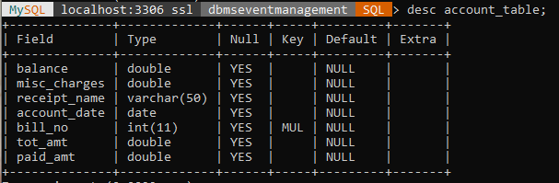

#### Describing the *bill*

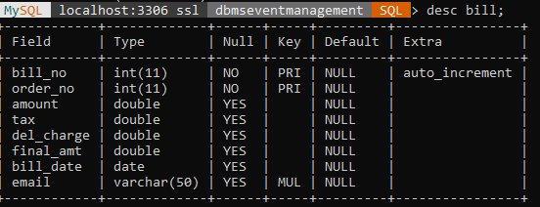

#### Describing the *department*

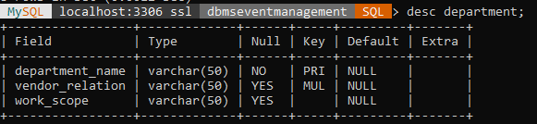

#### Describing the *event_table*

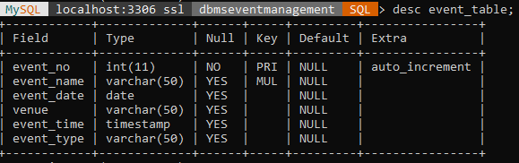

#### Describing the *feedback*

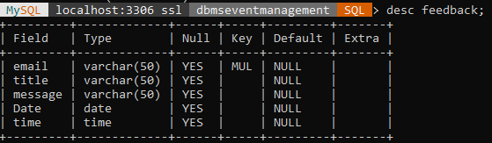

#### Describing the *inventory*

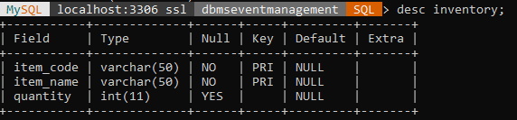

#### Describing the *login*

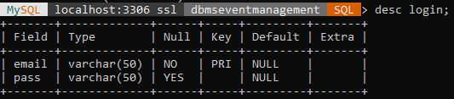

#### Describing the *registration*

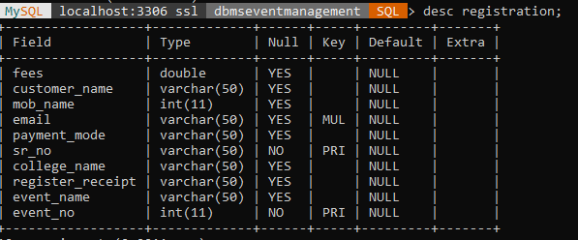

#### Describing the *sponsors*

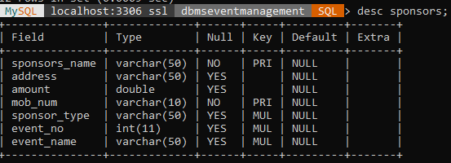

#### Describing the *sponsorship_package*

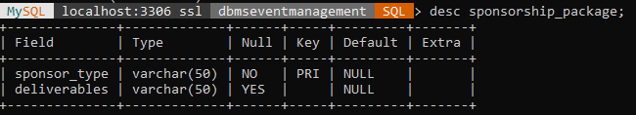

#### Describing the *team*

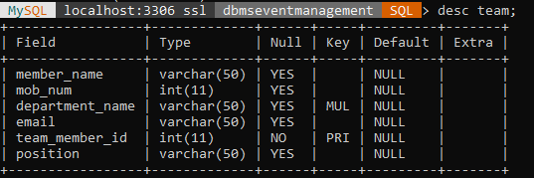

#### Describing the *vendors*

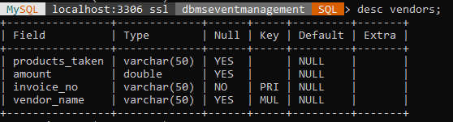

## [Queries to create tables](https://ghostbin.co/paste/88hux3)(🔗)

## 

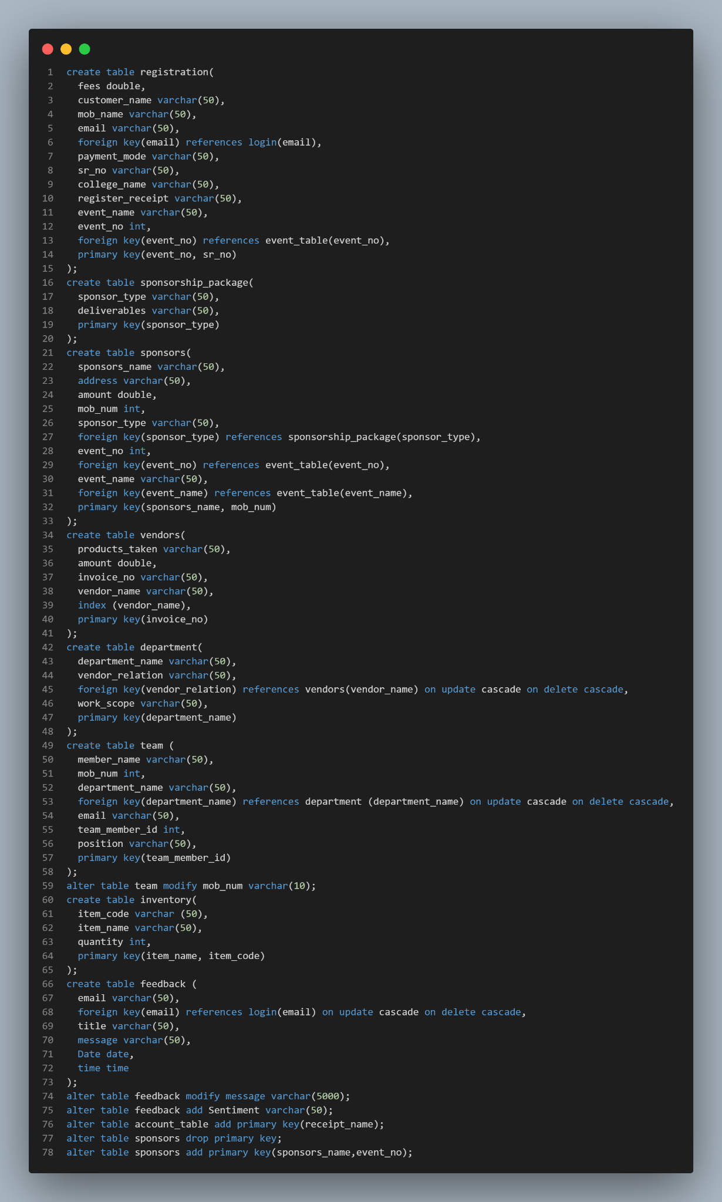

## [Queries to insert data](https://ghostbin.co/paste/9mqfu)(🔗)

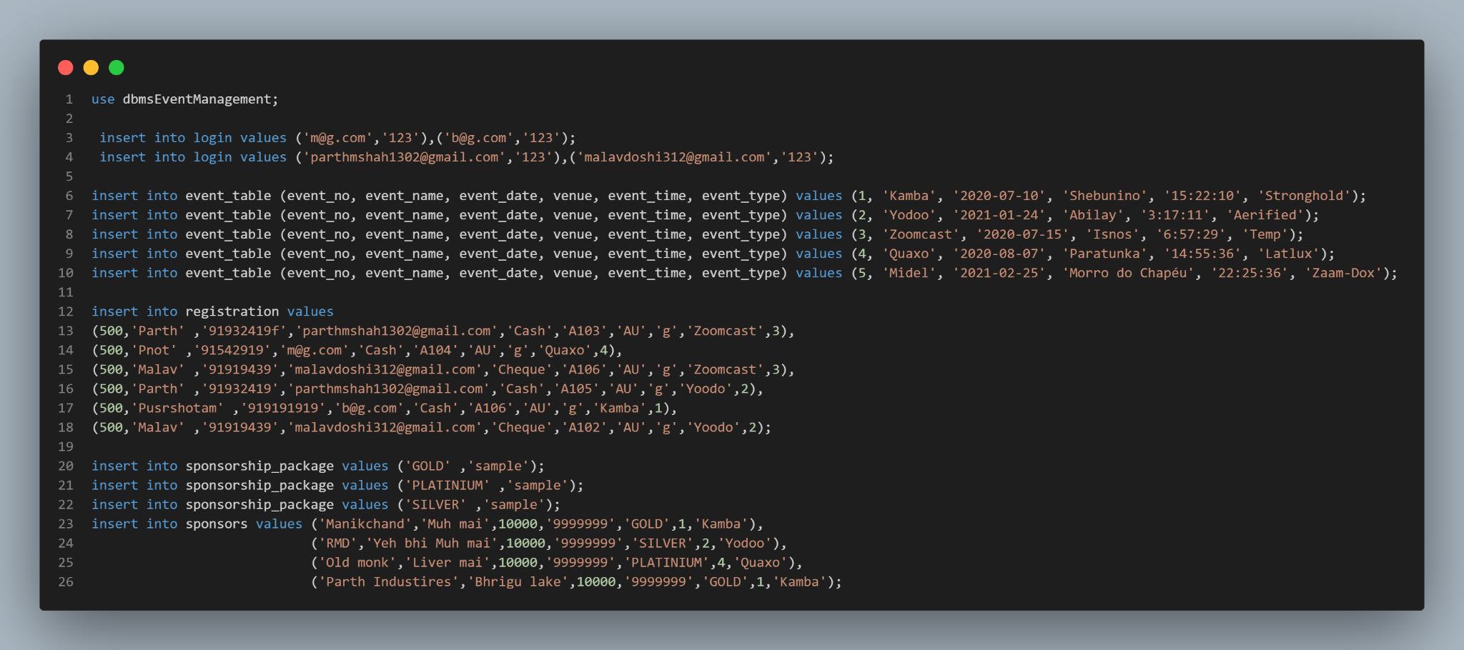

## Stored Procedures and Functions

### Following procedure provides a filter of events according to the venue. We also call a function to show the number of upcoming events.

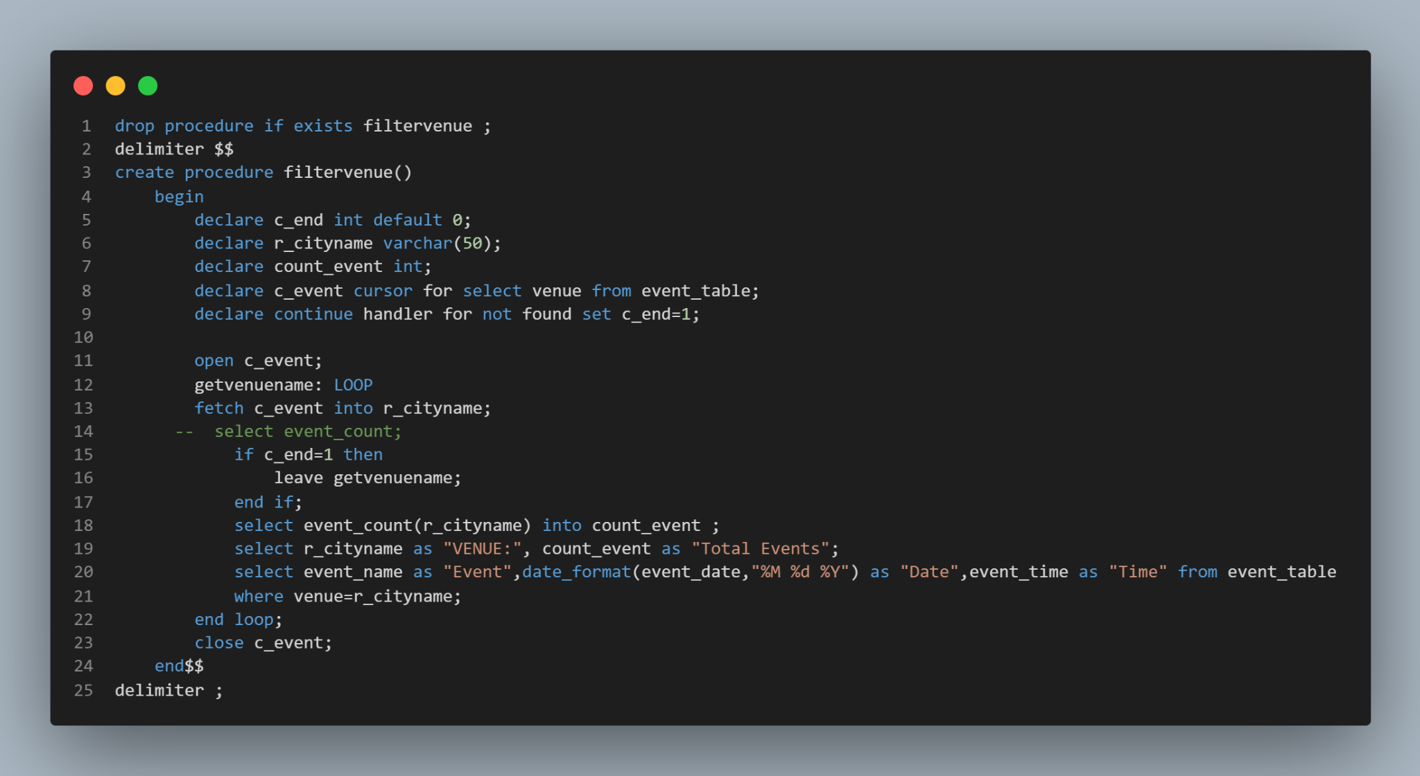

#### Filtervenue procedure on the frontend

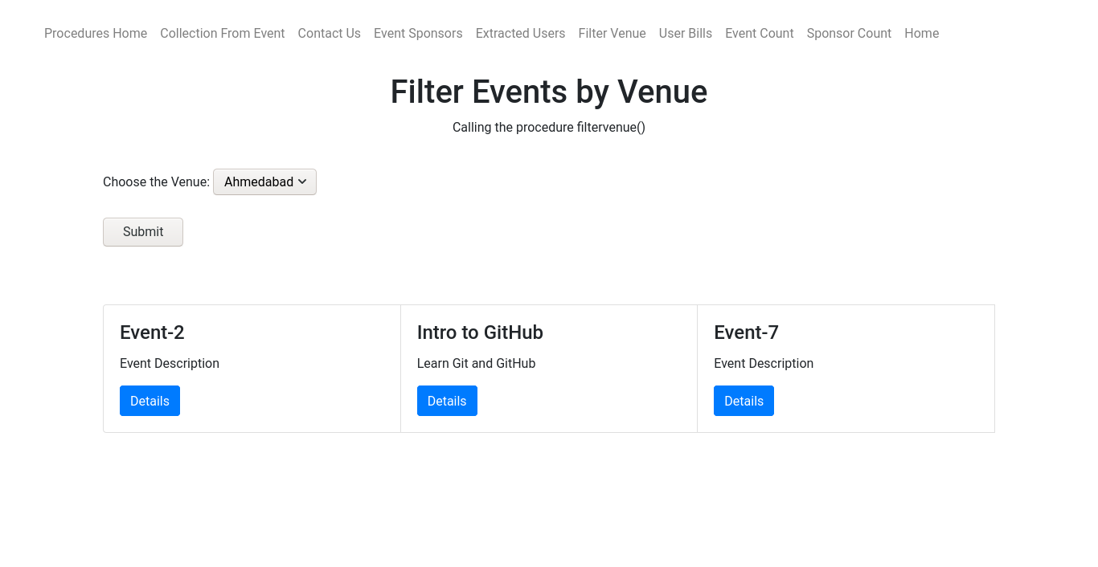

#### Code in backend used to call the procedure

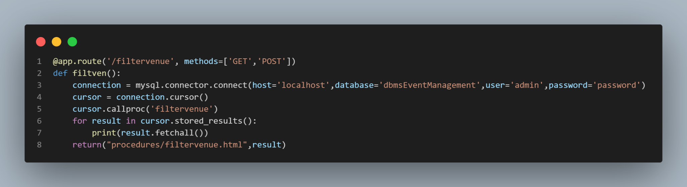

### Following procedure provides us the list of attendees of a particular event.

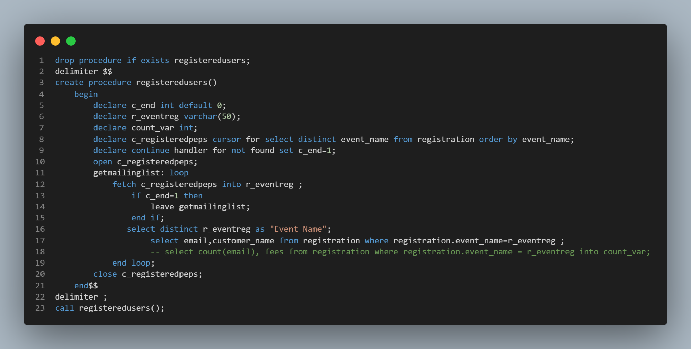

#### Output on the front-end when we call the procedure registeredUsers()

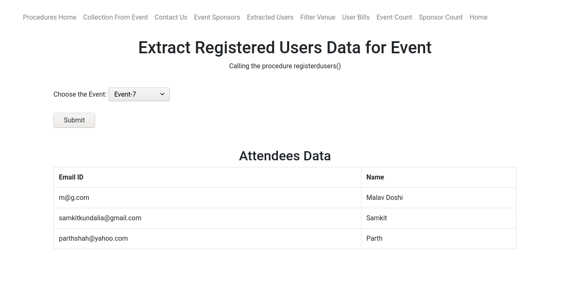

### Following procedure provides us with the total collection of the event where we pass the event name and the fees in the entry fees in a particular event as parameters.

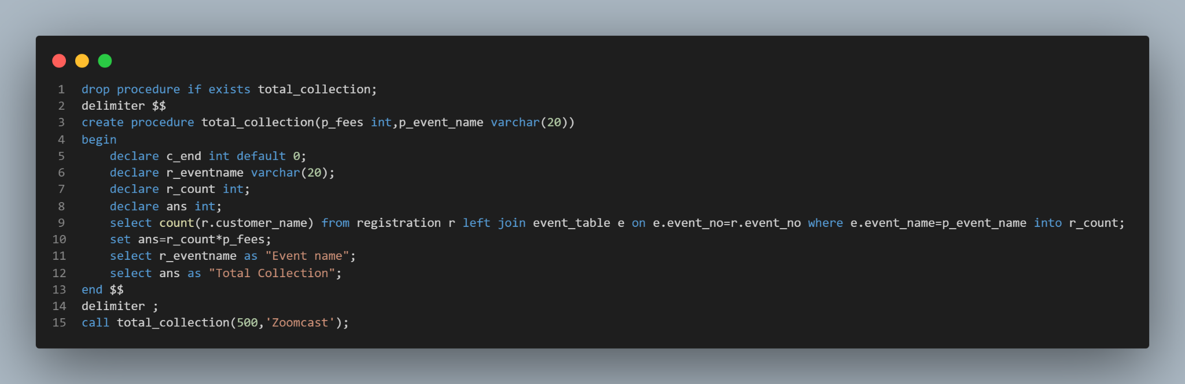

#### Output on the front-end when we call the procedure total_collection()

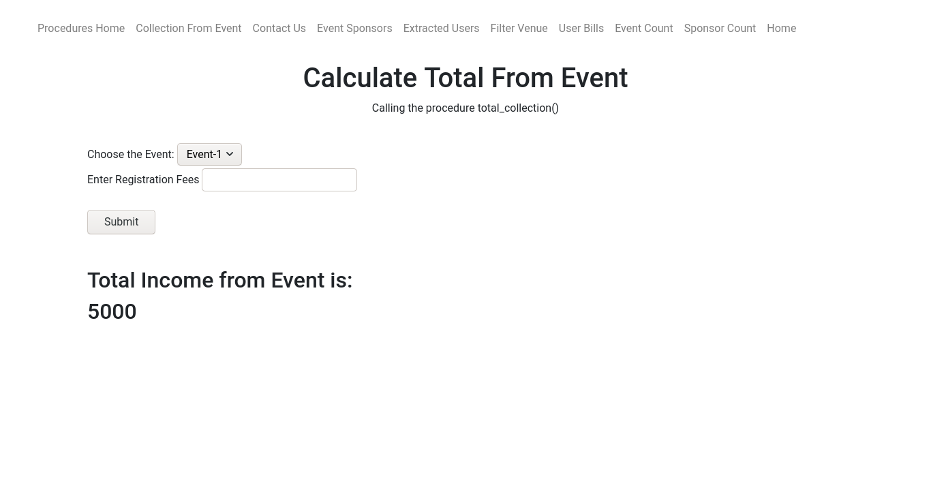

#### Code in backend used to call the procedure

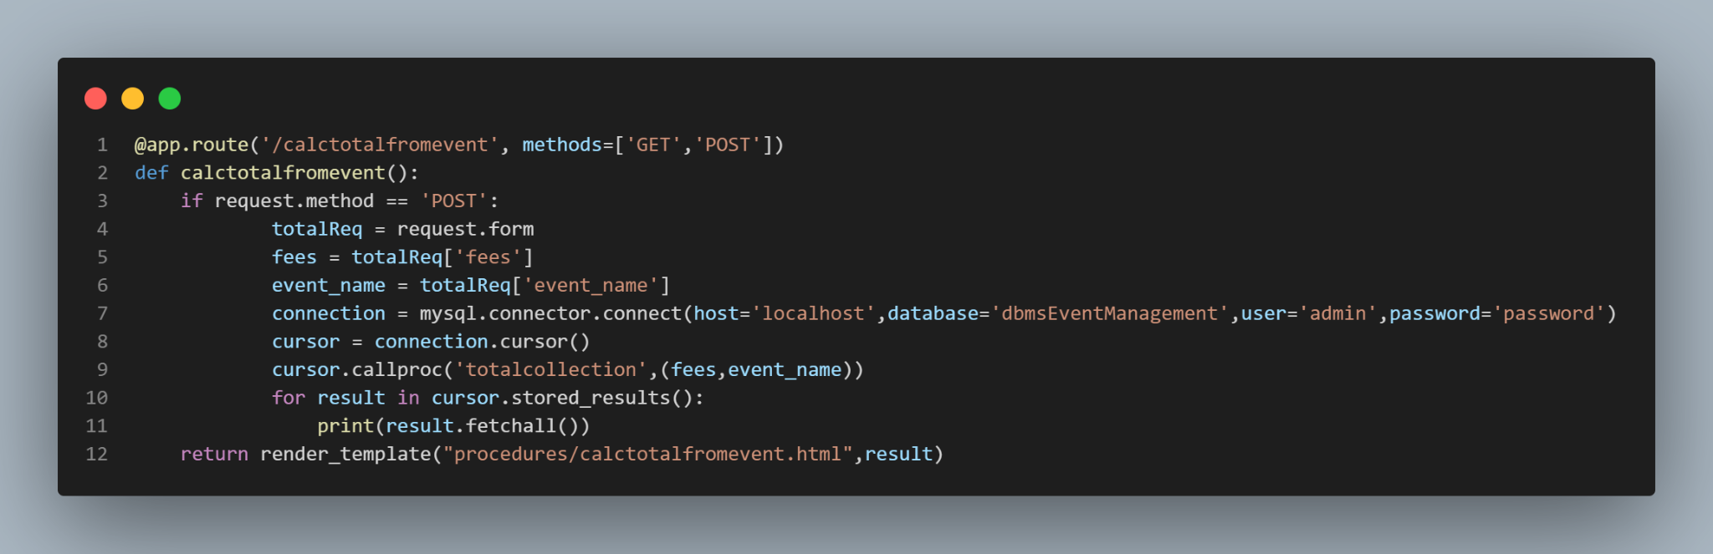

### Following procedure helps the user to get in touch with members of the event team in a particular department.

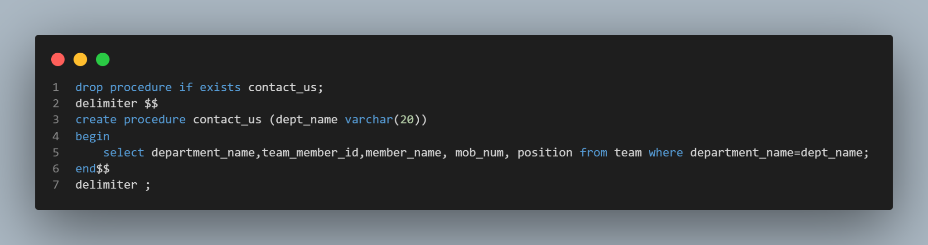

#### Output when we call the procedure contact_us() on the frontend

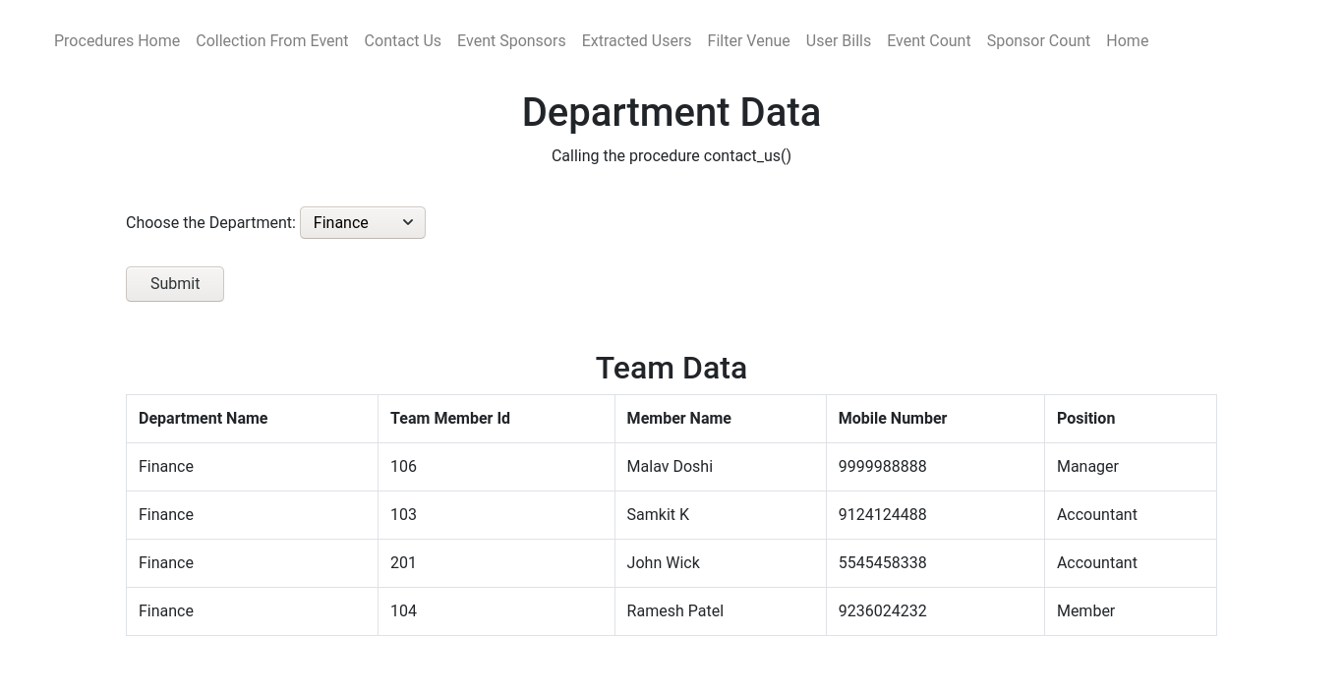

#### Code in backend used to call the procedure

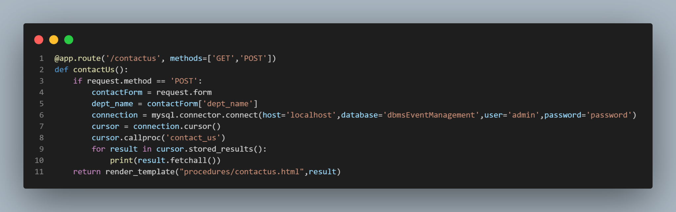

### Following procedure takes the feedback message as it’s parameter. It makes an API call in real time through Python which parses in the message from MySQL and returns the sentiment of the message. This saves countless hours that is spent on reading and understanding the messages in detail.

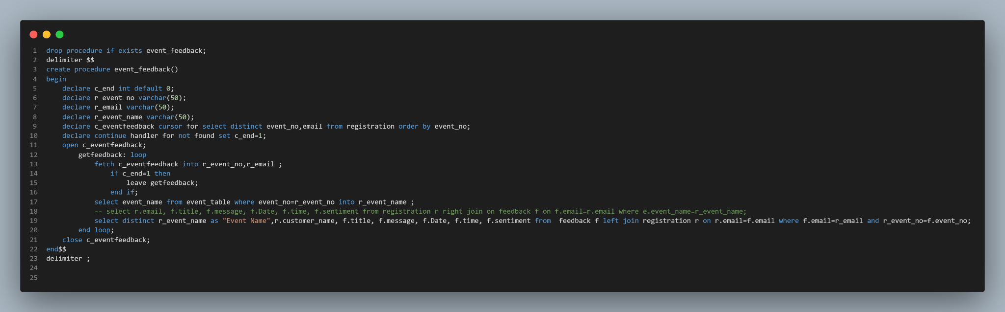

#### Input message, category 1:

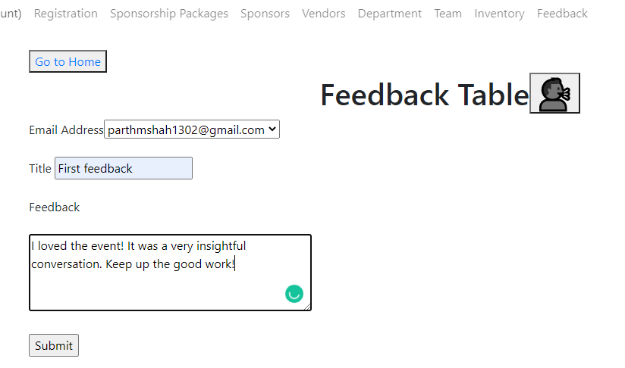

#### Returned sentiment of joy:

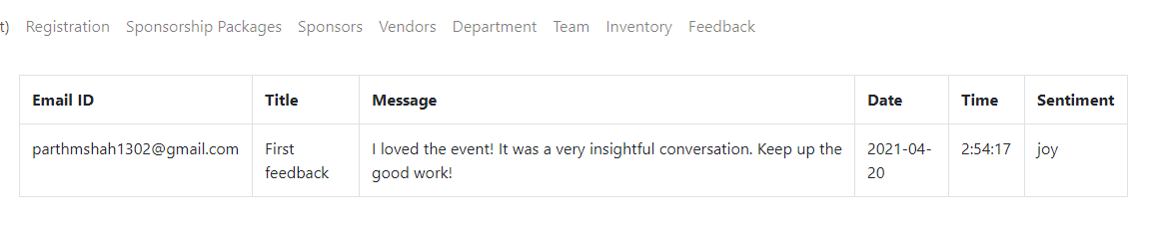

#### Input message, category 2:

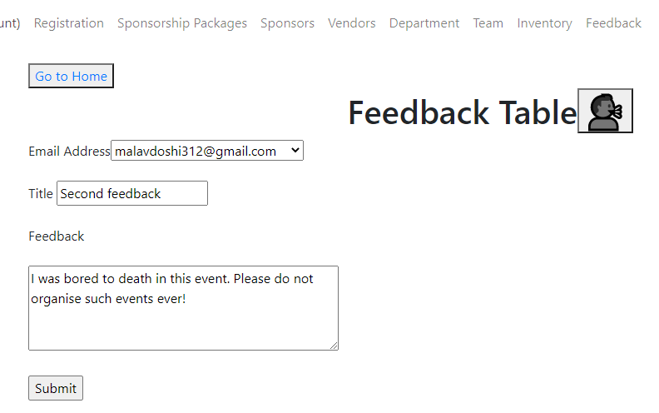

#### Returned sentiment of sadness:

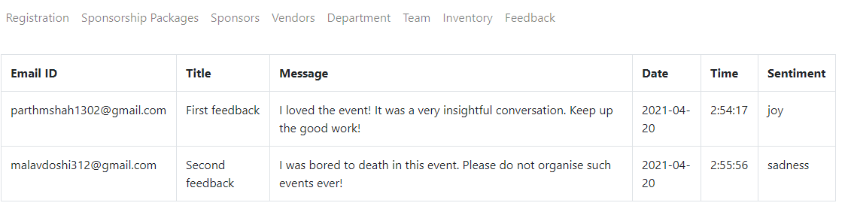

### Following bill provides the user with the bill of registration of the event that one did.

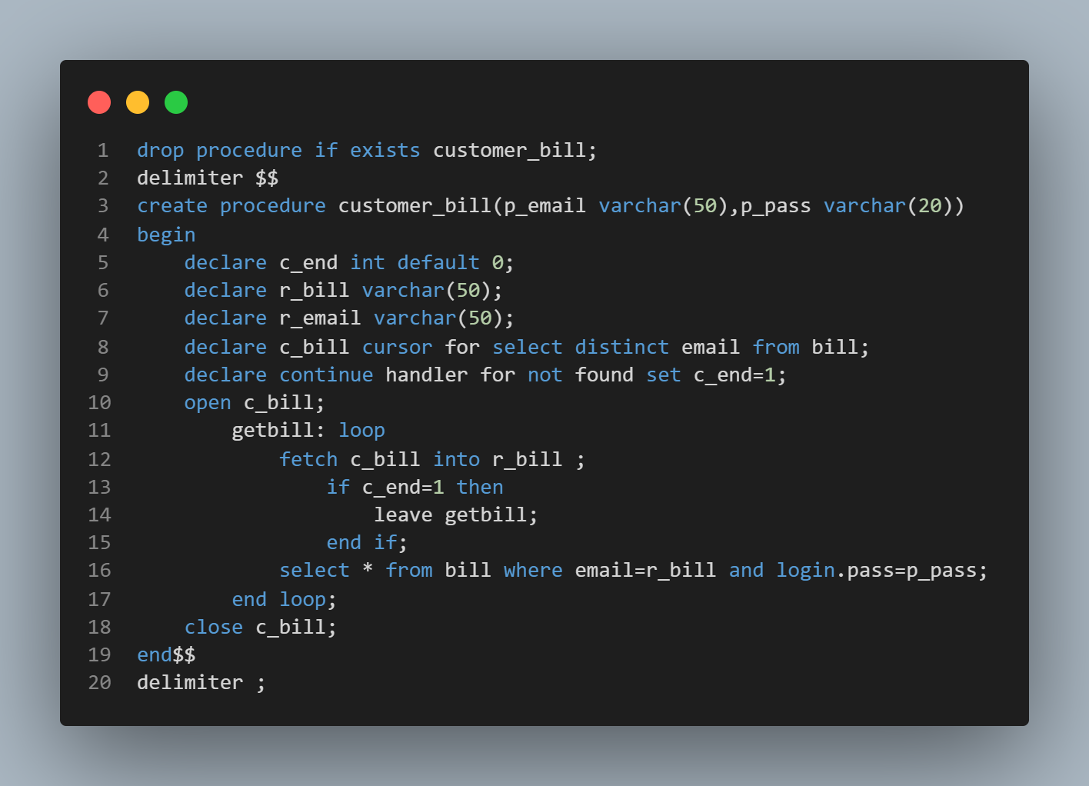

#### Output when we call the procedure customer_bill() on the frontend

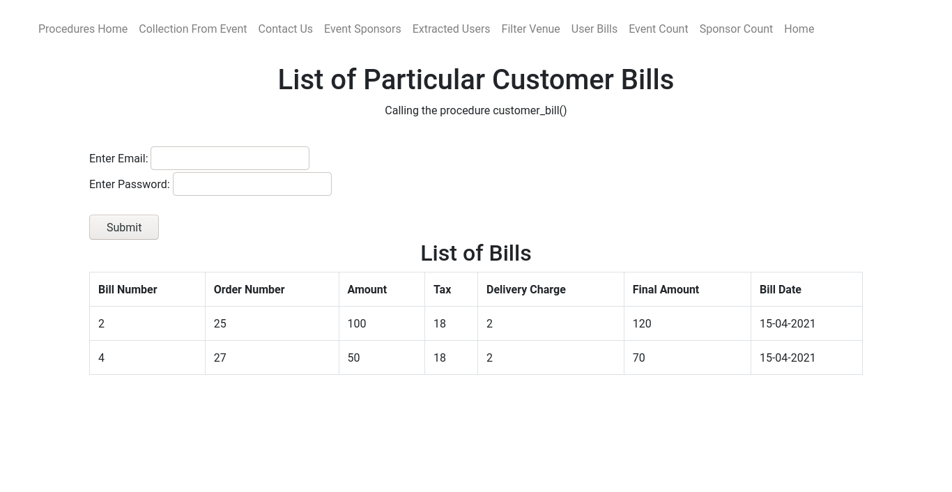

#### Code in backend used to call the procedure

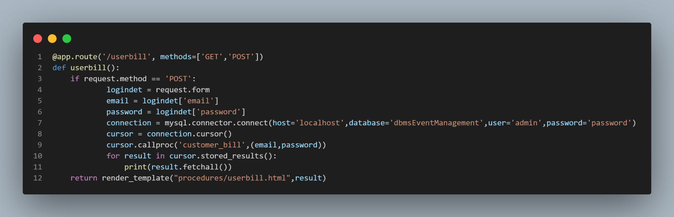

### Following procedure displays all the sponsors of a particular event.

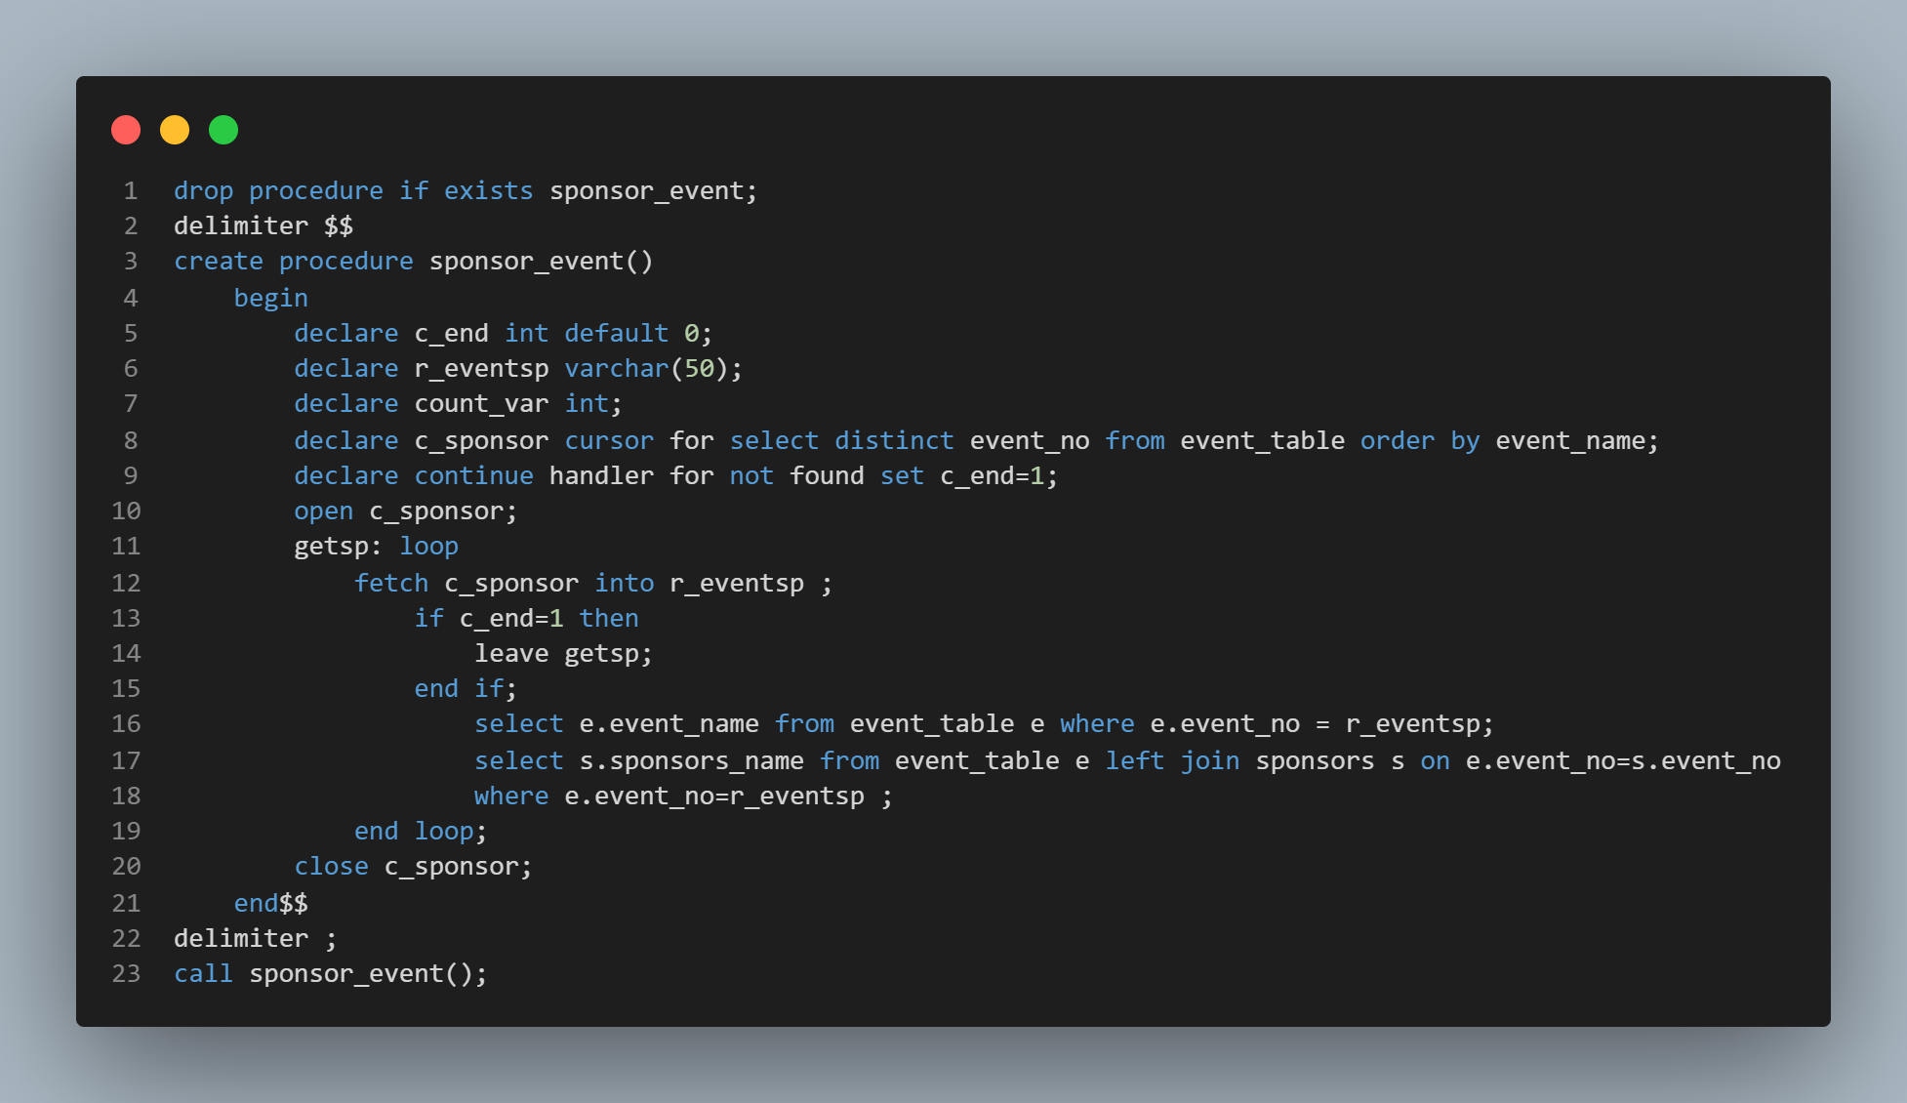

#### Output when we call sponsor_event() on the front-end

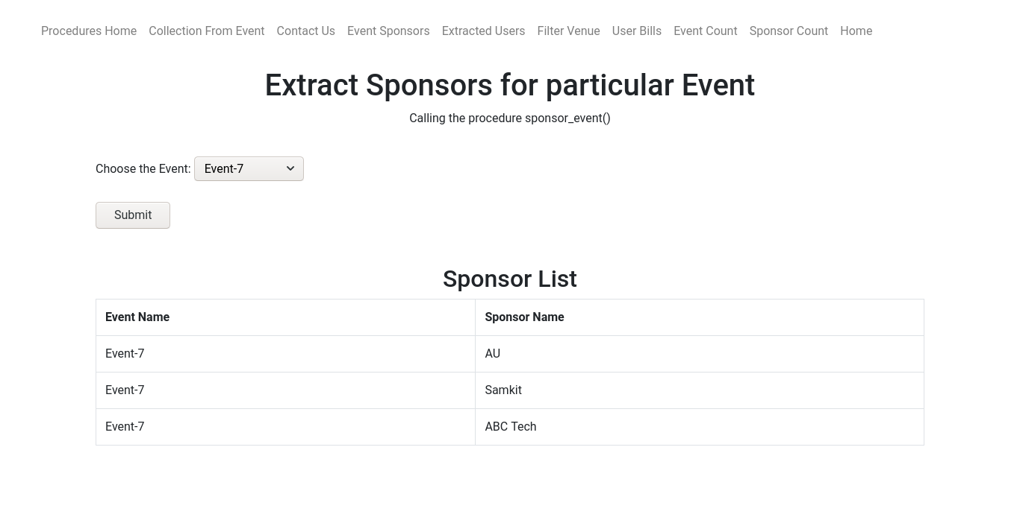

#### Code in backend used to call the procedure

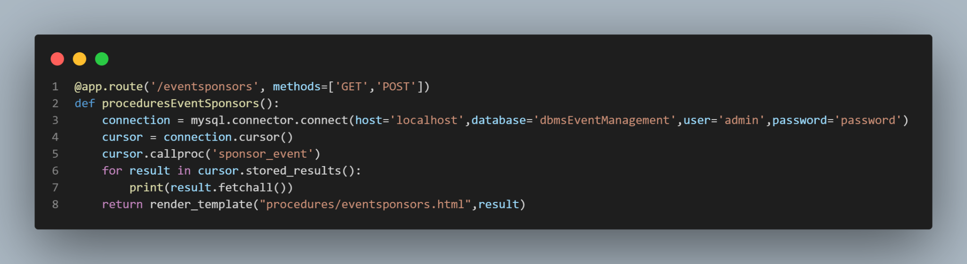

### Following function displays the number of events that are upcoming in a particular venue.

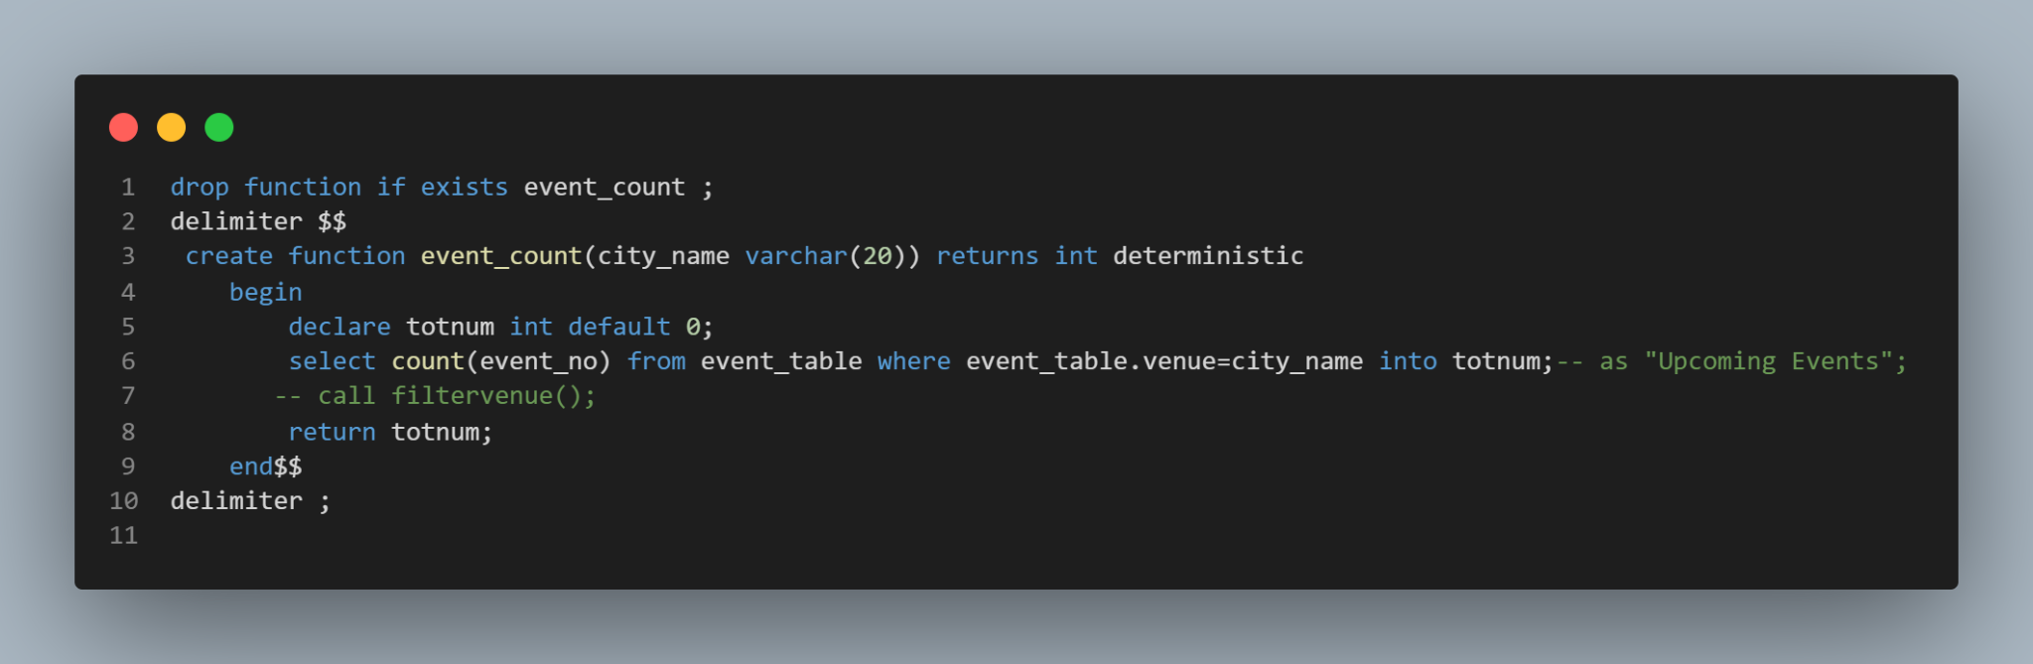Output when we call the function event_count

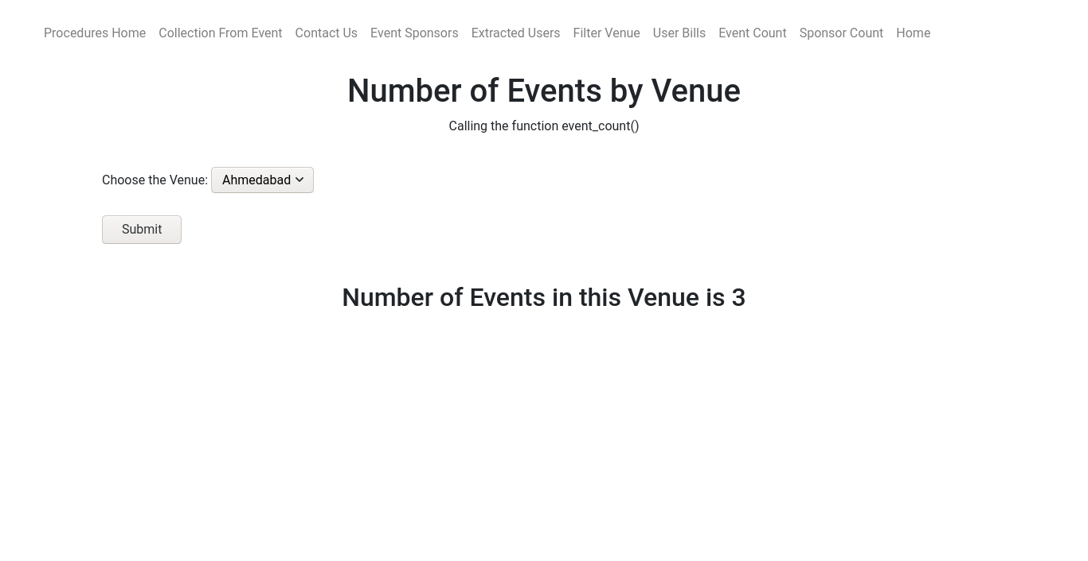

#### Code in backend used to call the procedure

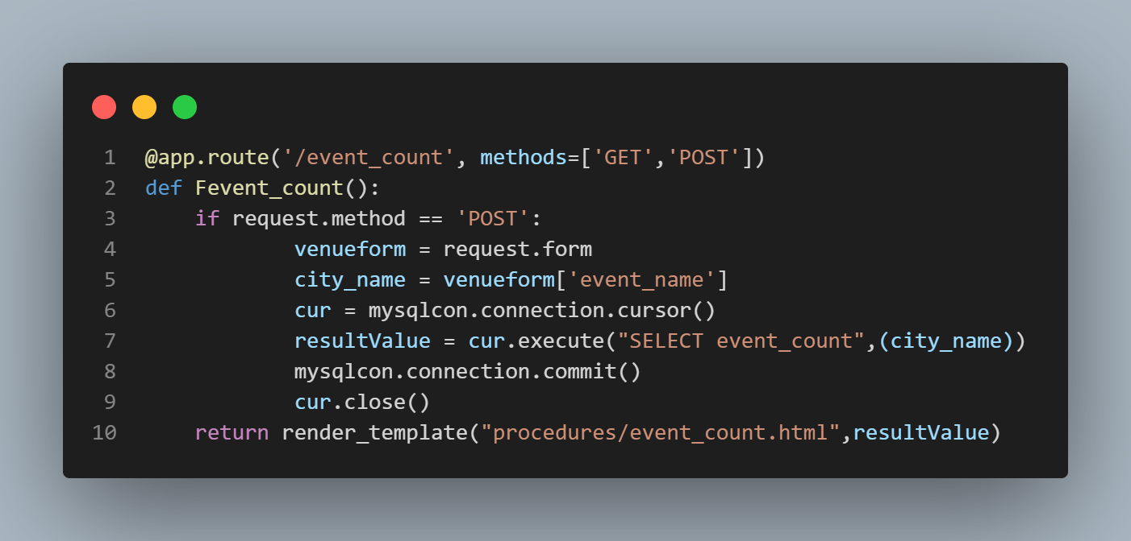

### Following function calculates the total amount associated with a particular bill.

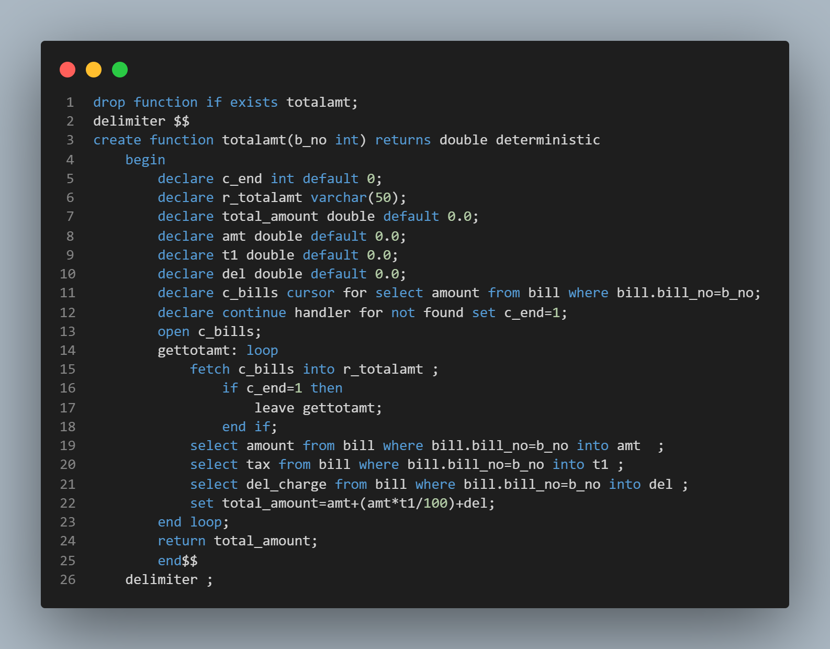

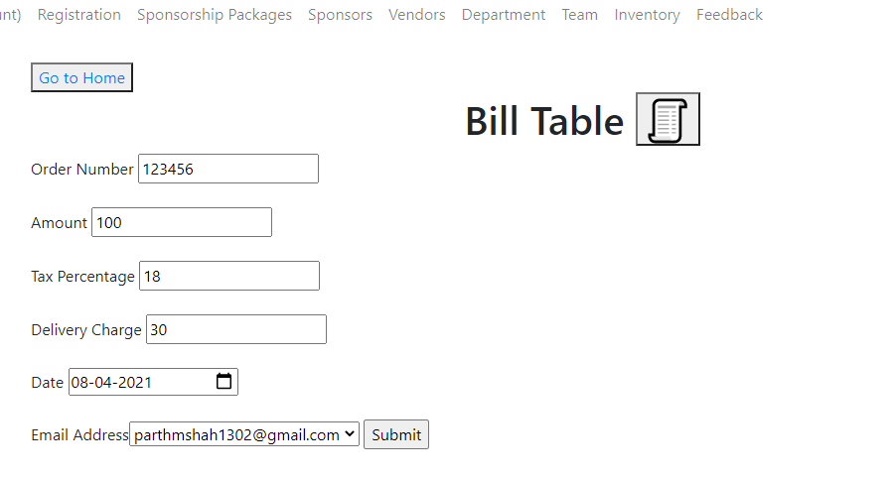

#### Procedure called to populate the Final Amount field

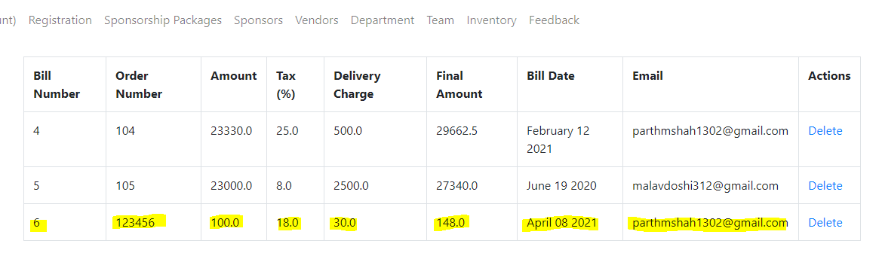

#### 

#### 

#### 

#### Python code that implements this to the Frontend

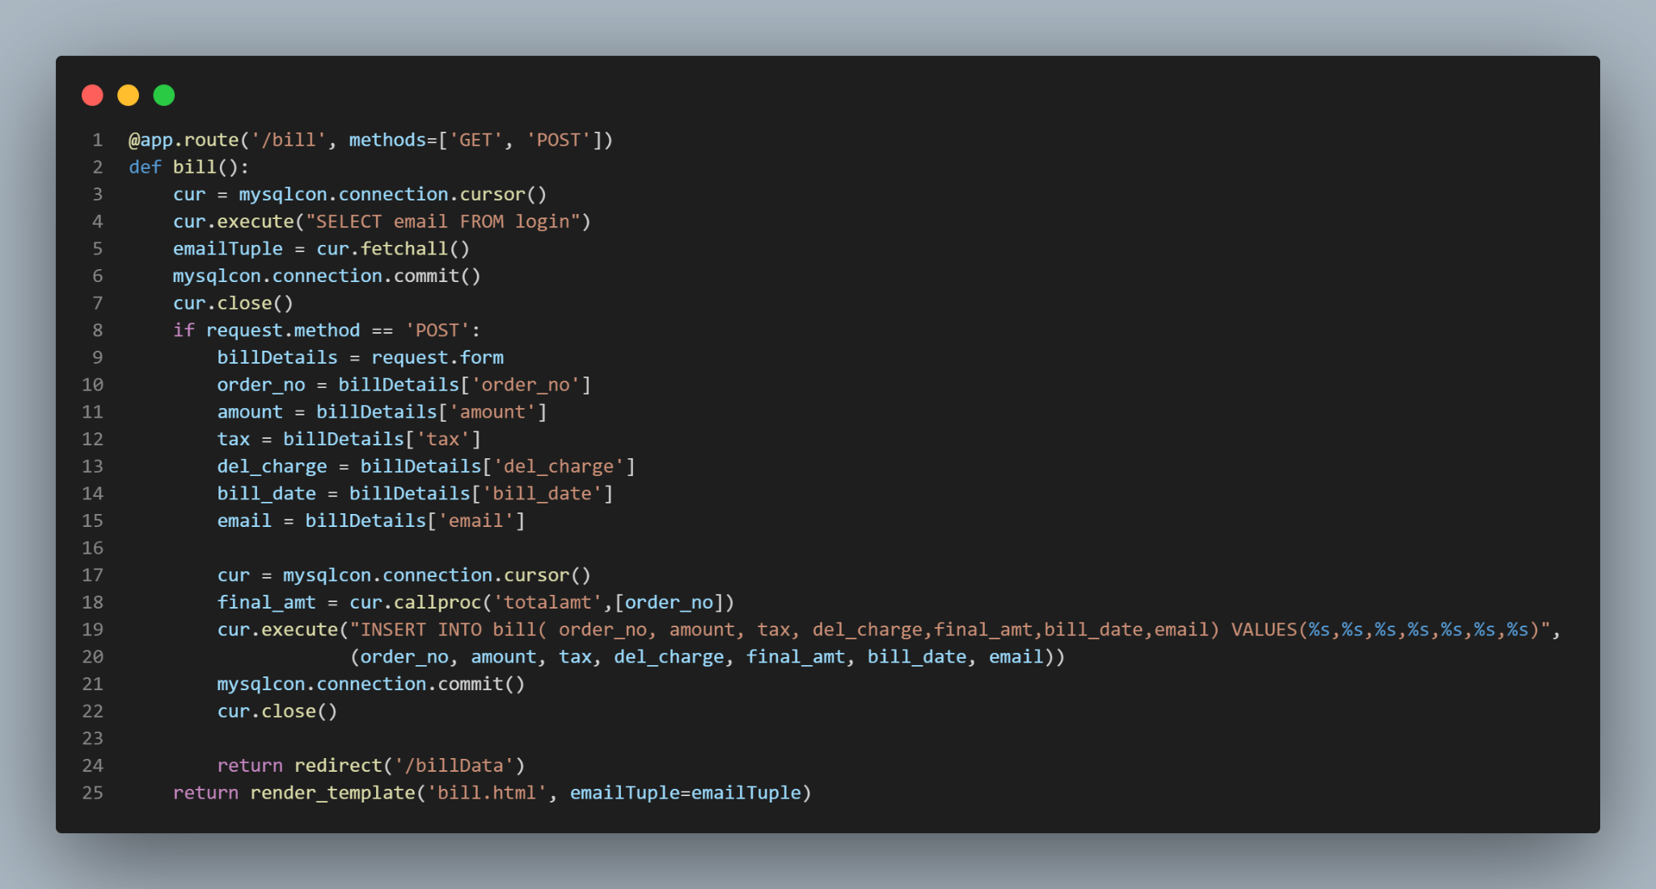

### Following function displays the total number of sponsors associated with a particular event.

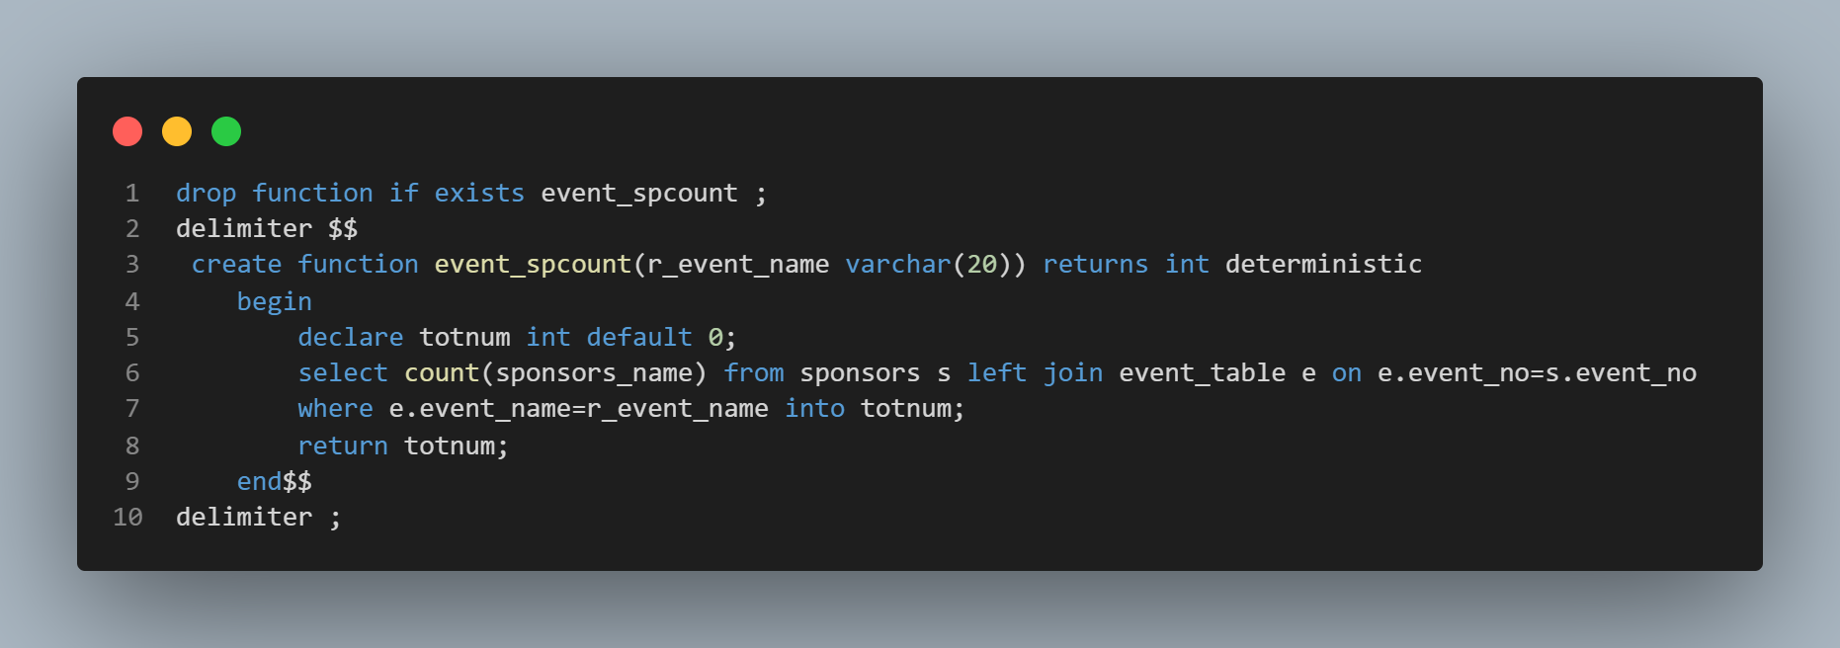

#### Output when we call the function event_spcount() on the frontend

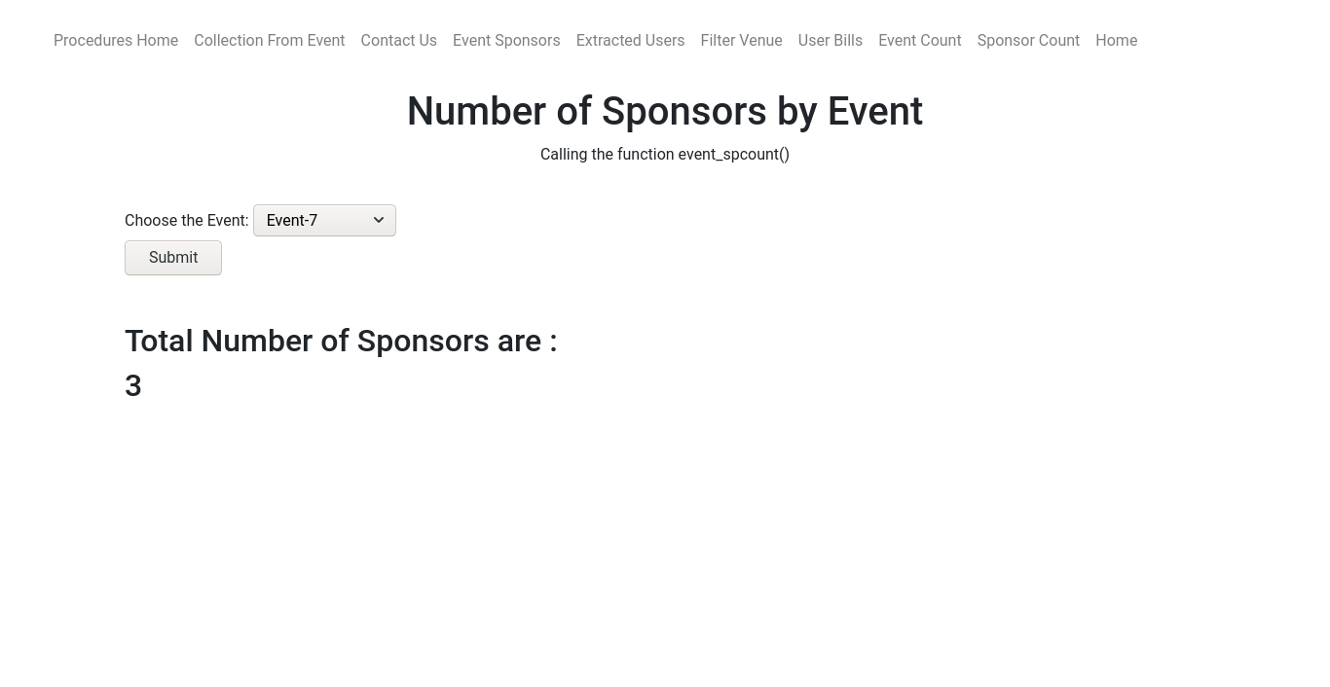Code in the backend used to call the procedure

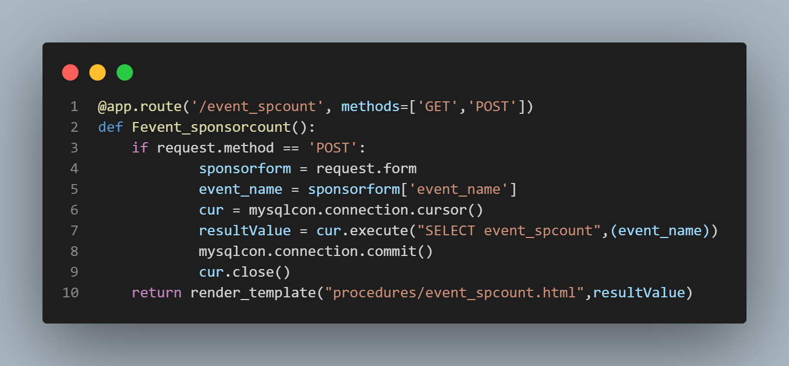

## Triggers

### Trigger to display error messages by checking whether the email exists in the database on inserting and updating .

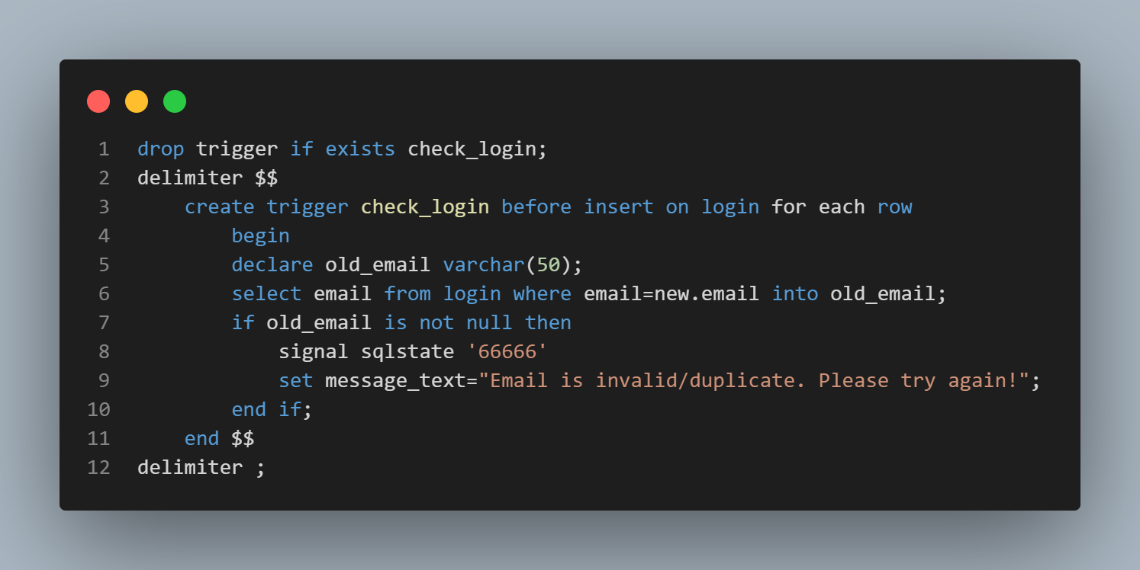

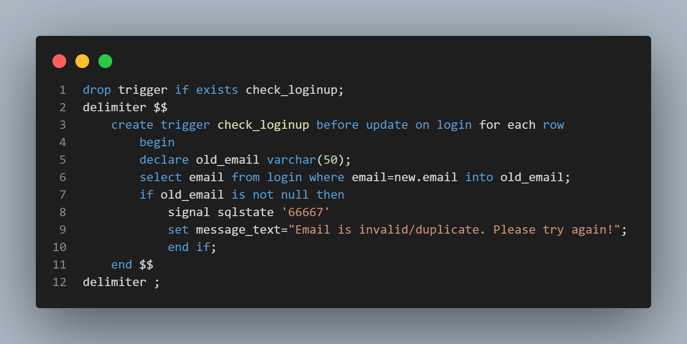

#### Entering a normal email address:

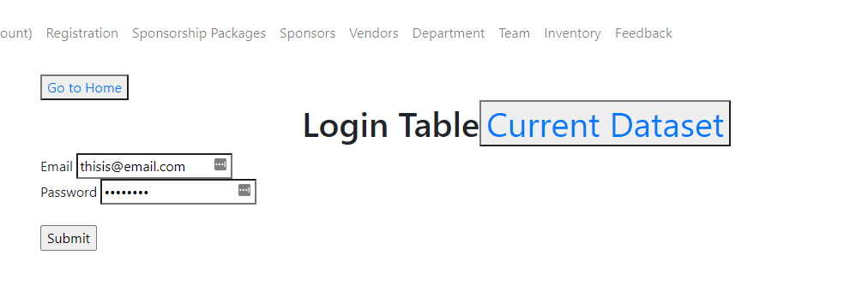

#### Data added successfully:

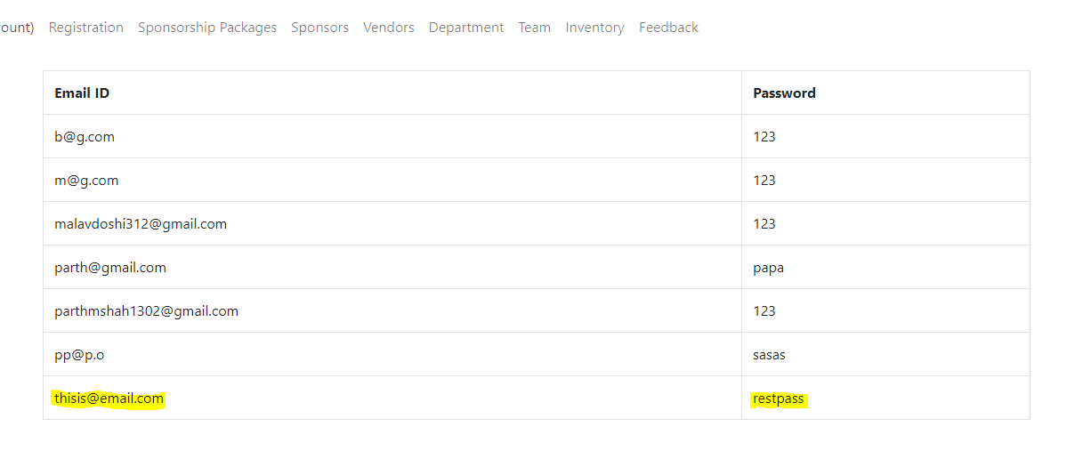

#### Trigger fired successfully:

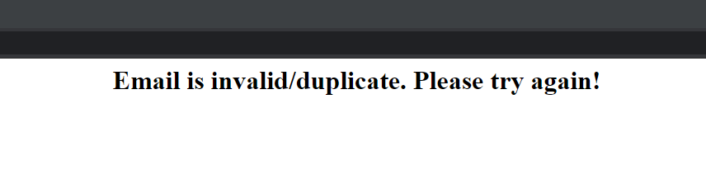

#### 

#### 

#### Connection with the Frontend

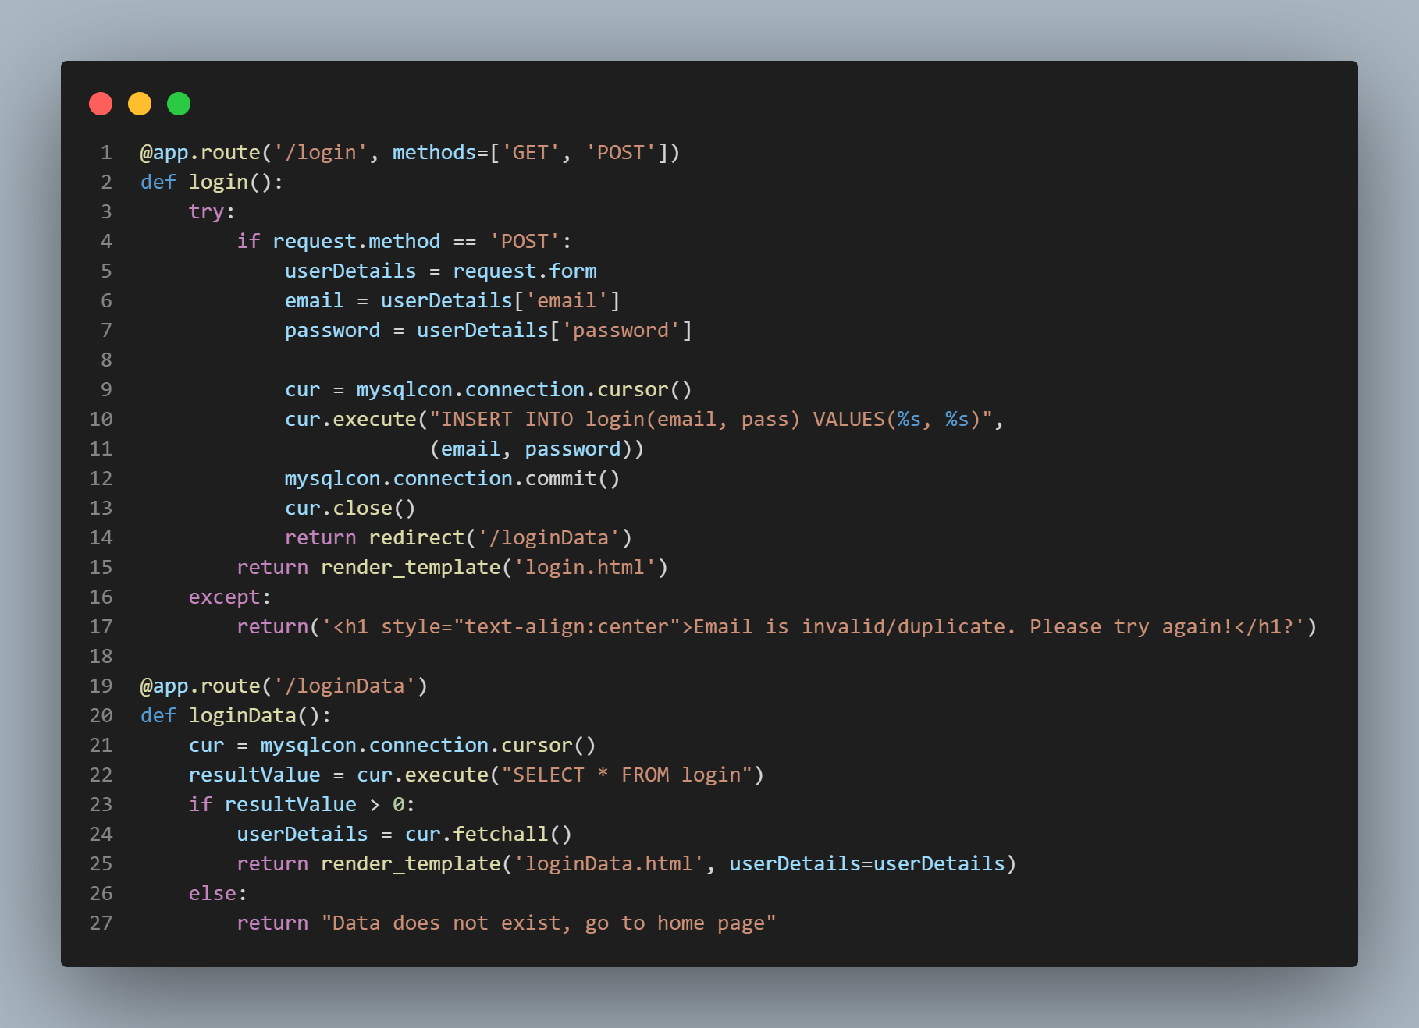

### Trigger to check whether or not is the email valid on inserting and updating

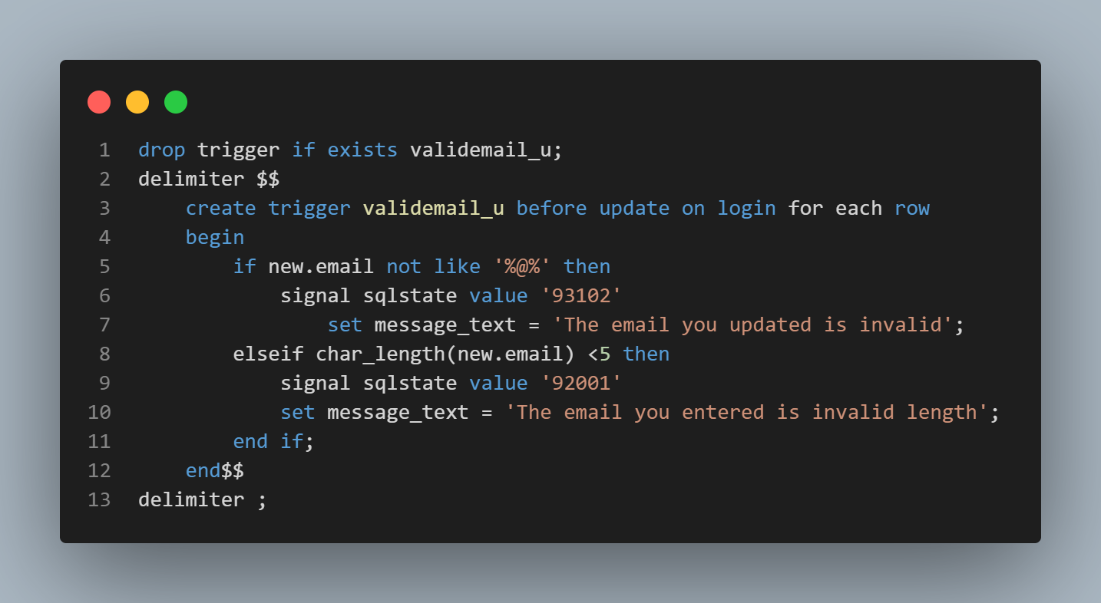

#### Adding an abnormal email to fire the trigger:

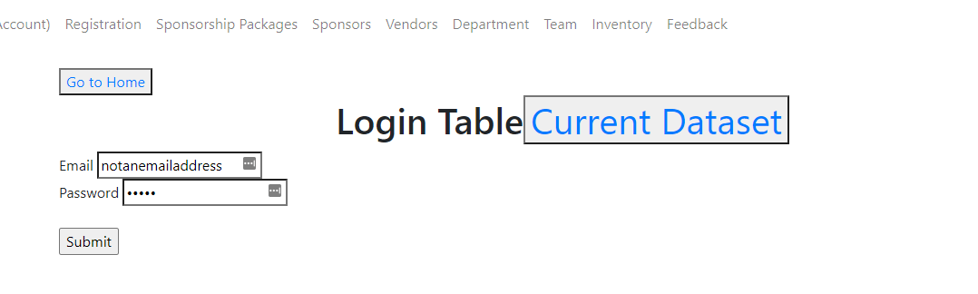

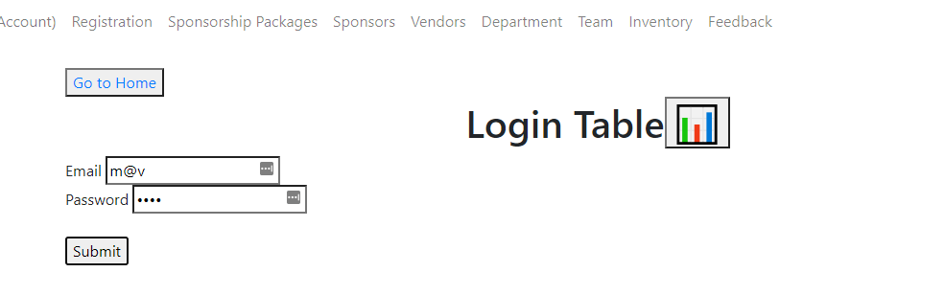

#### Trigger fired successfully:



#### Connection with the Frontend



### Trigger to delete records from child table registration , feedback and sponsors when deleted in the parent table event_table.

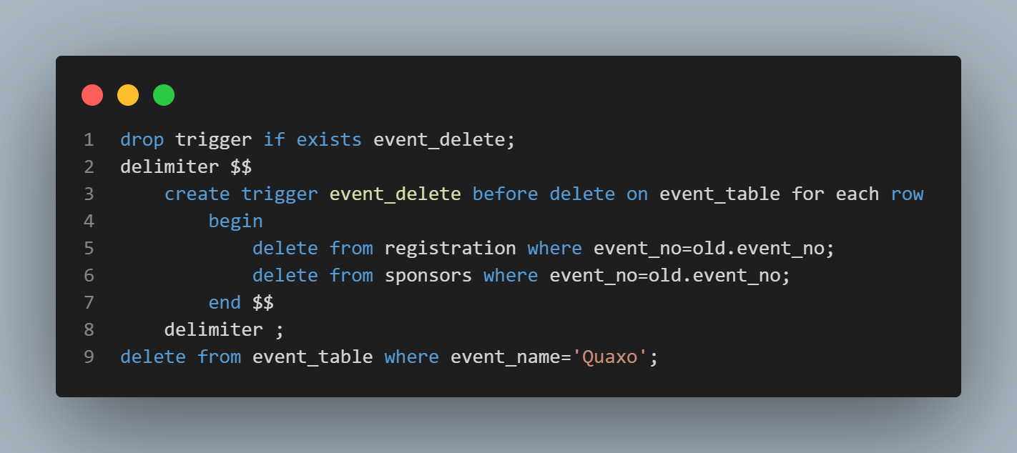

#### Following is the database before deleting from Event Table

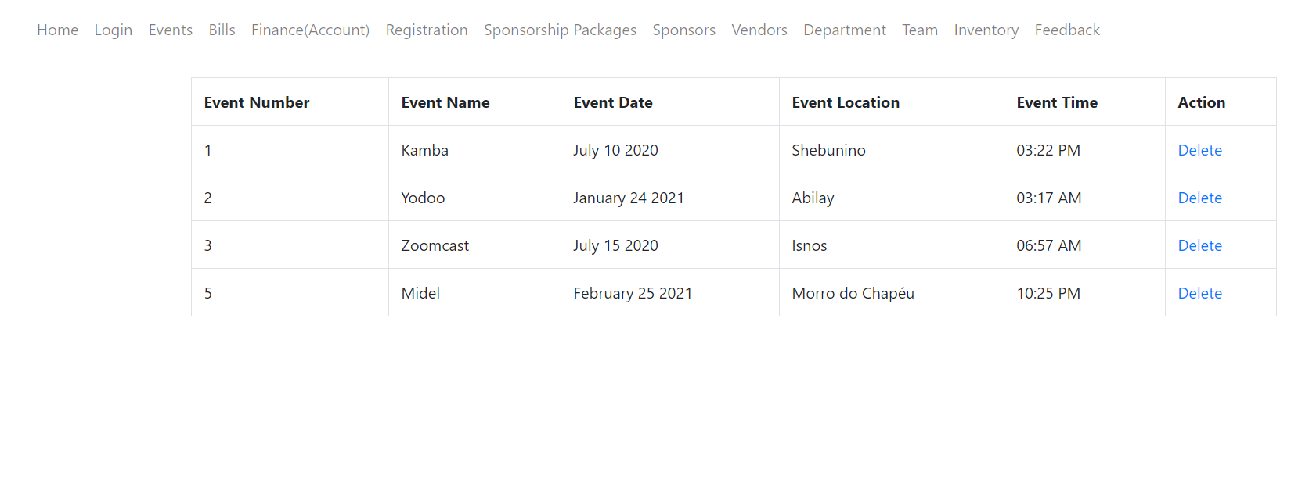

#### Following is the database before deleting from Sponsors.

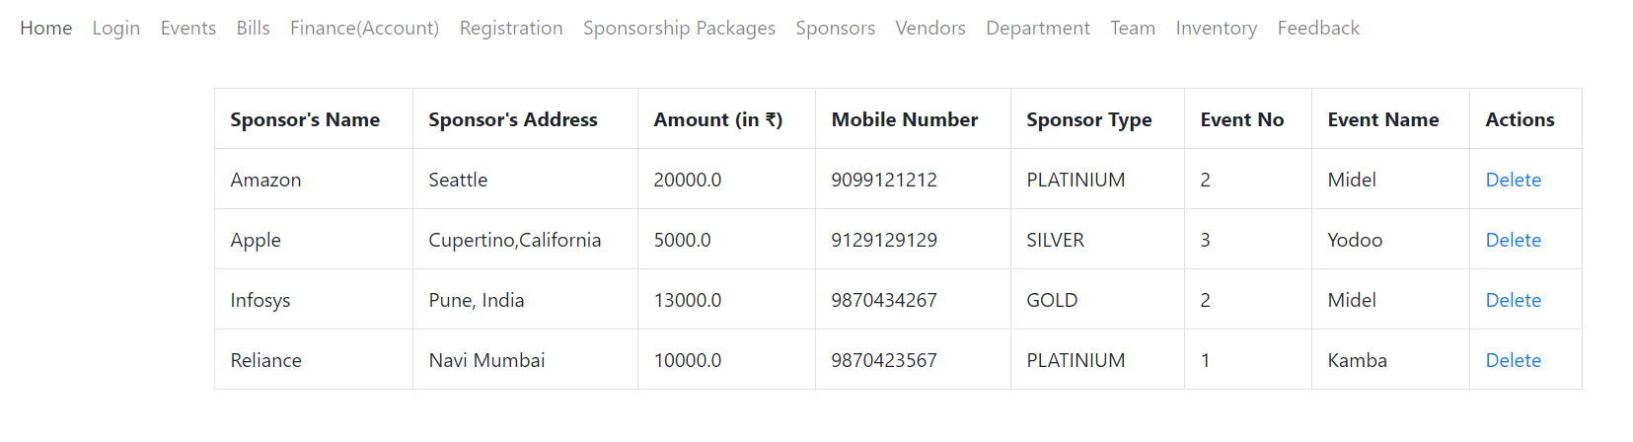

#### Following is the database before deleting from Registration.

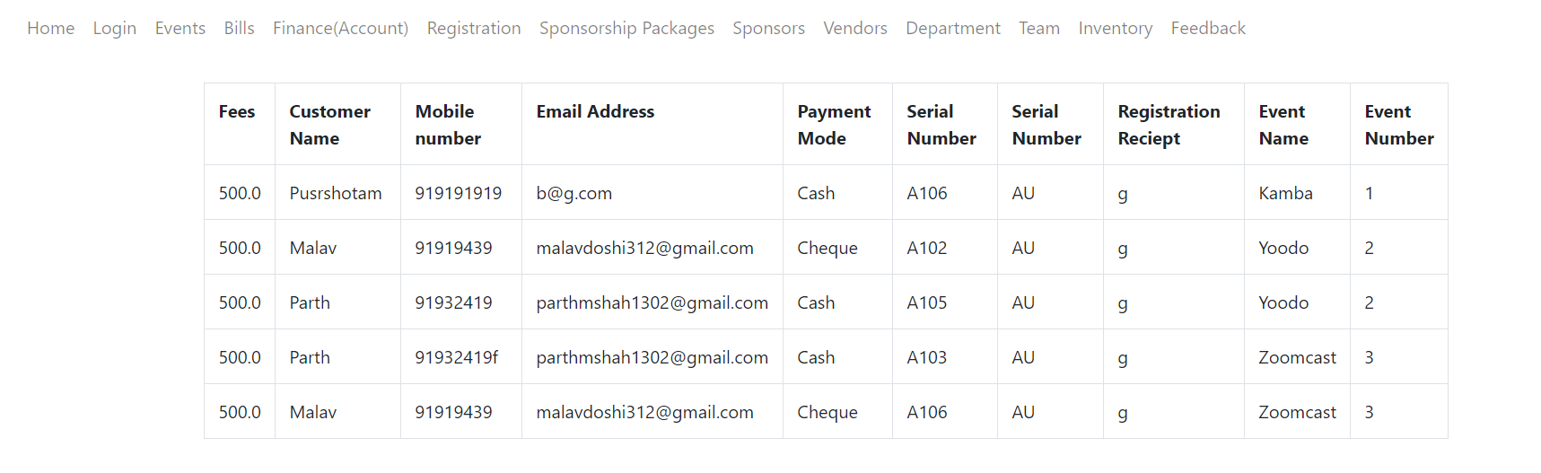

### Trigger to delete records from child table bill, registration,feedback when deleted in the parent table login.

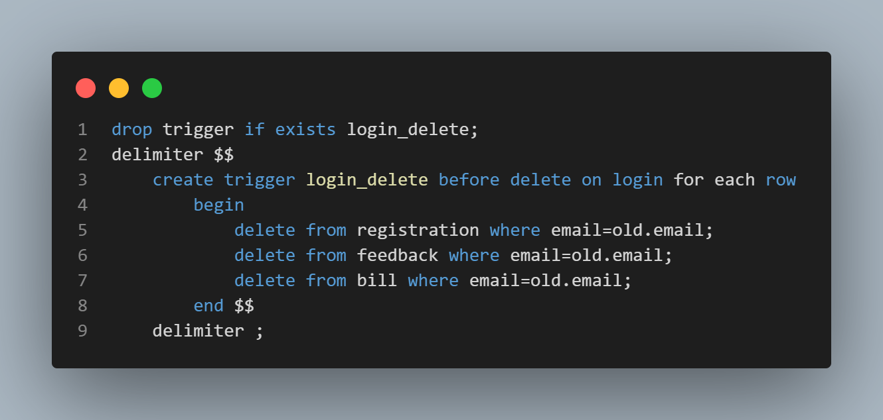

#### Following is the data before any record is deleted from login

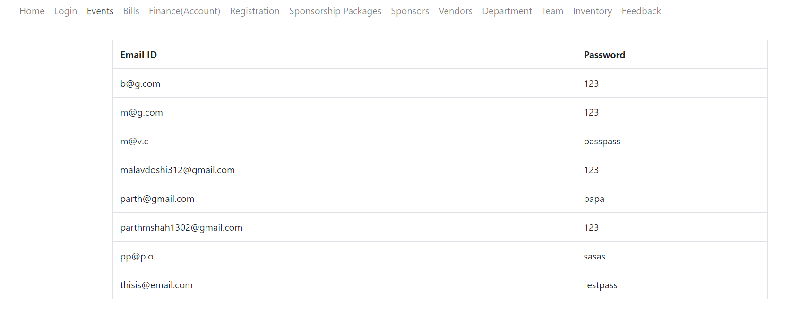

#### Following is the data from bill table

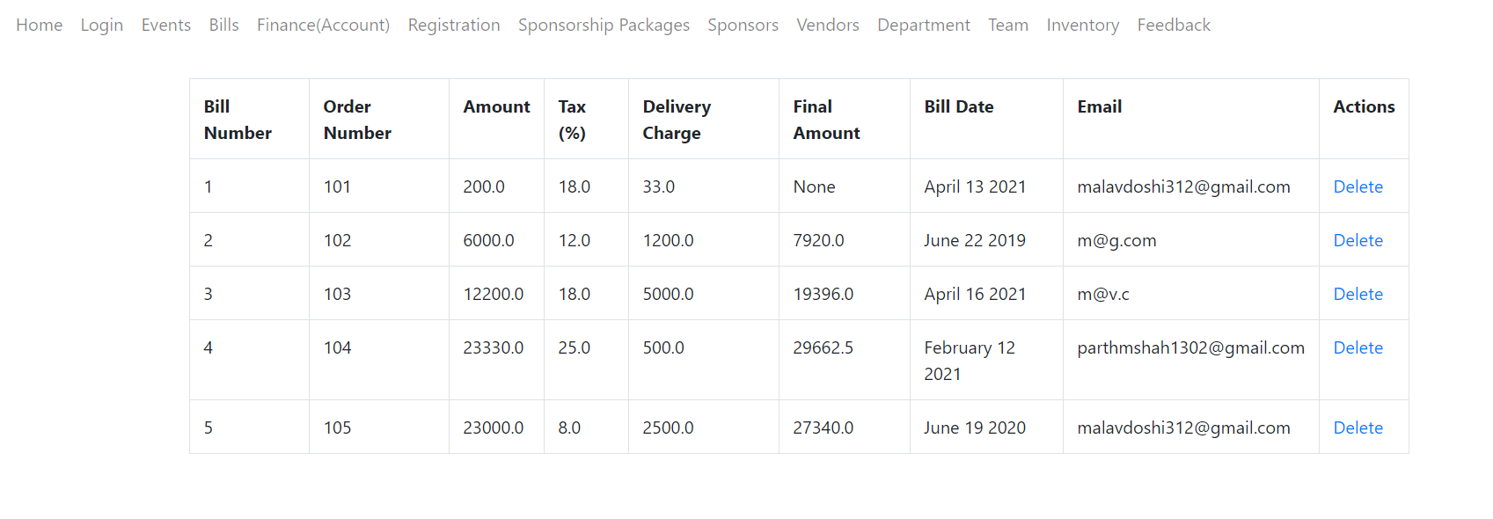

#### Following is registration table before delete



#### Following is the feedback table before delete

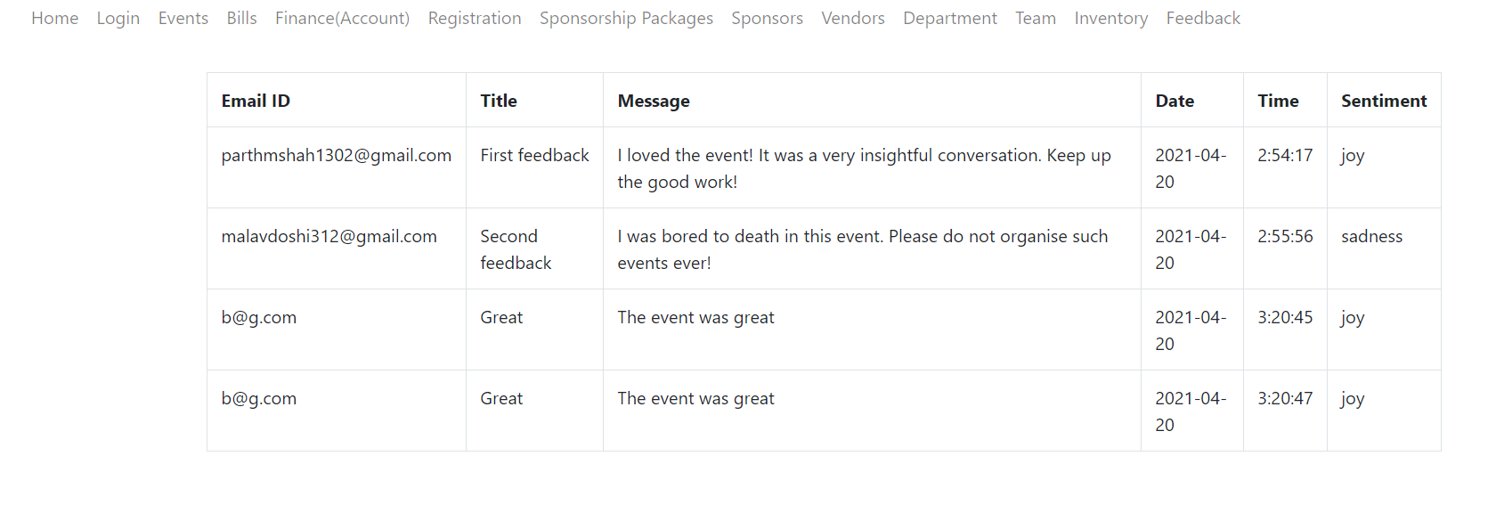

### Trigger to delete records from the child table team, vendors when deleted in the parent table department.

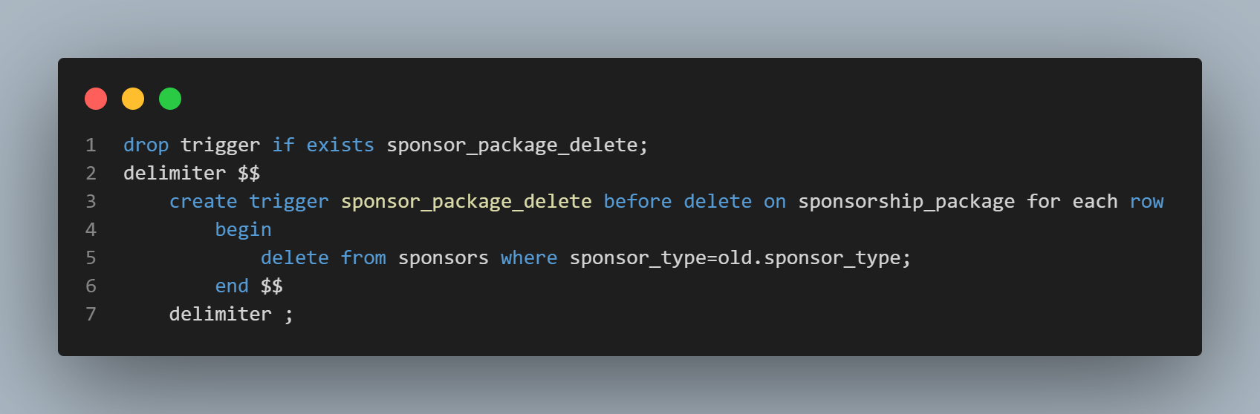

#### Following is the department table before deleting

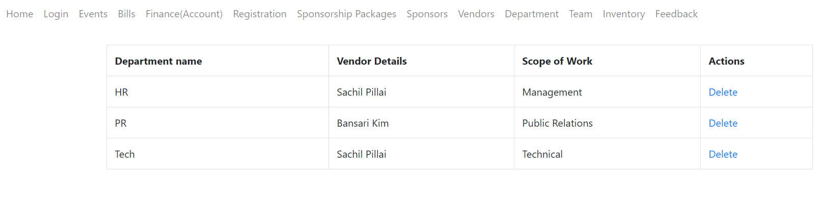

#### Following is the table vendors before delete

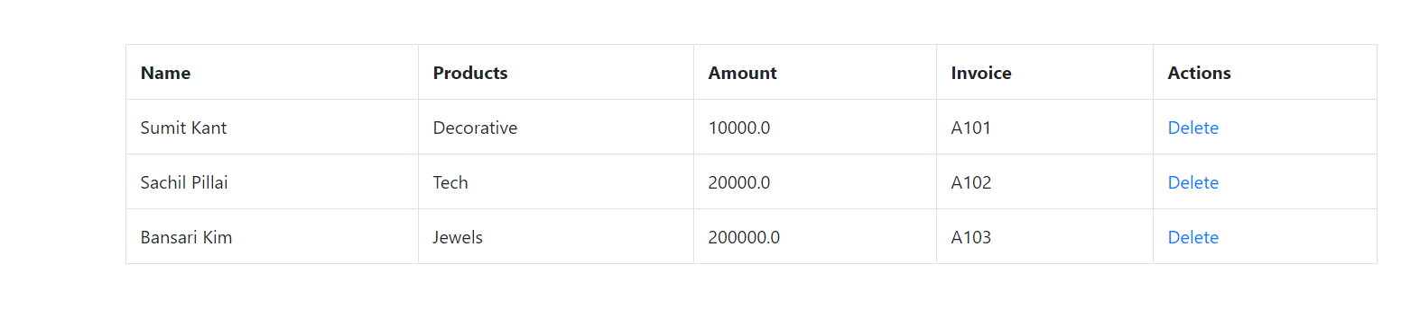

#### Following is the table team before delete

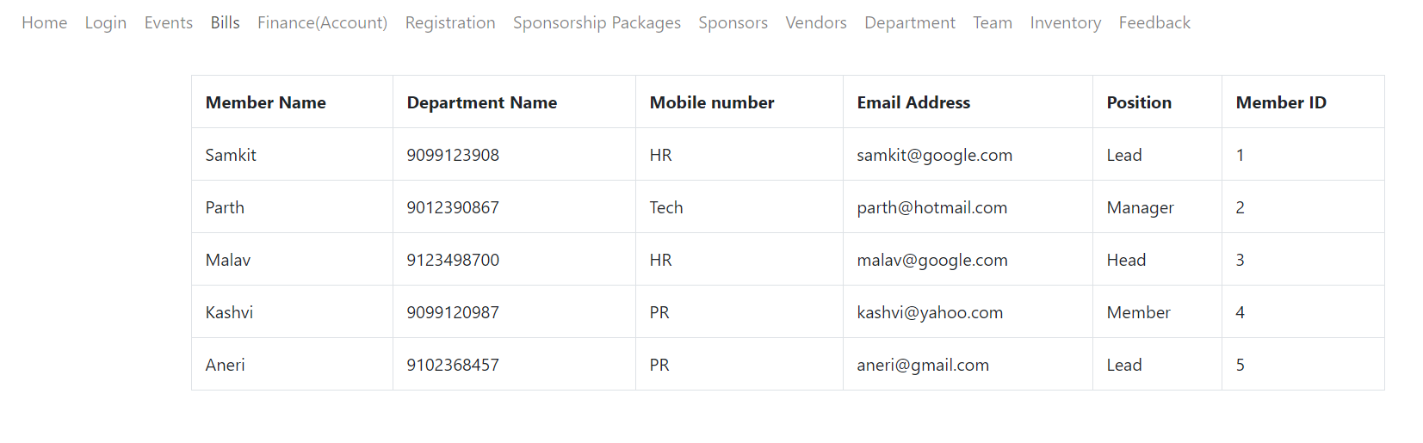

### Trigger to update records from child table registration , feedback and sponsors when deleted in the parent table event_table.

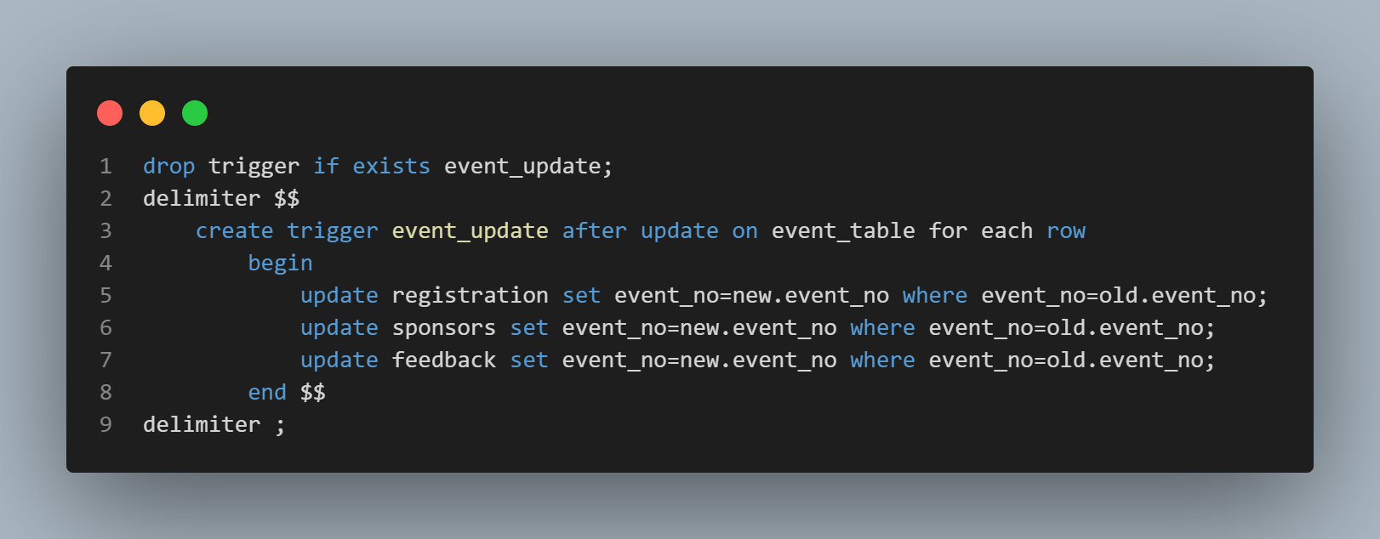

### Trigger to delete records from child table registration , feedback and sponsors when deleted in the parent table event_table.

